SACLEFORCE PROJECT

PROJECT TITLE:-

**A CRM APPLICATION FOR WHOLESALE RICE MILL**



SUBMITTED By

**NANDINEE JAYANT DURGE**

[**nandineejayantdurge@gmail.com**](nandineejayantdurge@gmail.com)

**INDEX**

Table of contents page no.  
Abstract 4

Chapter – 1 Introduction 5 - 8  
 1.1 Objective 5 - 6  
 1.2 Scope 6 - 8  
 1.3 What you will learn?8  
 1.4 Application 8  
Chapter – 2 Problem Statements9  
Chapter 3 Technical Architecture10 - 11  
Chapter – 4 Project Implementation Steps12 - 63  
 4.1 Introduction To Salesforce12 - 15  
 4.1.1 Creating Developer12 - 13  
 4.1.2 Account Activation13 - 15  
 4.2 Object16 - 19  
 4.2.1 Create Supplier Object18  
 4.2.2 Create Rice Mill Object19  
 4.2.3 Create Consumer Objects19  
 4.2.4 Create Rice Details Objects19  
 4.3 Tabs20 - 22  
 4.3.1 Creating A Custom Tab20 - 21  
 4.3.2 Creating Remaining Tabs21 - 22  
 4.4 The Lightning App23 - 25   
 4.4.1 Create A Lightning App23 - 25  
 4.5 Fields26 - 37  
 4.5.1creating The Number Field In Rice Details Object27  
 4.5.2 Creating Junction Object28 - 29  
 4.5.3 Creating A Master-Detail Relationship30  
 4.5.4 Creating The Roll-Up Summary30 - 32  
 4.5.5 Creating Fields In Objects33  
 4.5.6 Creating Fields In Rice Mill Objects34  
 4.5.7 Creating Fields In Consumer Objects34  
 4.5.8 Creating Cross Object Formula Field In Consumer Object34 - 35  
 4.5.9 Creating The Validation Rule36 - 37  
 4.6 Page Layouts38 - 39  
 4.6.1 Creating The Page Layout38 - 39  
 4.7 Profiles40 - 42  
 4.7.1 Owner Profile40 - 41  
 4.7.2 Employer Profile41 - 42  
 4.7.3 Worker Profile42  
 4.8 Role & Role Hierarchy43 - 45  
 4.8.1 Creating Owner Role43 - 44  
 4.8.2 Creating Employer Roles44 - 45  
 4.9 Users46 - 47  
 4.9.1 Create User46  
 4.9.2 Creating Another User47  
 4.9.3 Create Another User47  
 4.10 Permission Sets48  
 4.10.1 Create OWD Setting48   
 4.11 Report49 - 54  
 4.11.1 Create Report50 - 51  
 4.11.2 Sharing Report To Owner51 - 52  
 4.11.3 Create A Report Folder52 - 54  
 4.12 Dashboards55 - 59  
 4.12.1 Create Dashboard Folder56  
 4.12.2 Create Dashboard56 - 59  
 4.13 Apex60 - 63  
 4.13.1 Creating An Apex Class(ConsumerRecord) 61 - 62   
 4.13.2 Creating An Apex Trigger63  
  
Chapter- 5 What I Gained From The Project64

Chapter- 6 Conclusion65

**Chapter – 7 Future Enhancements...66**

**ABSTRACT**

What is Salesforce?

Salesforce is a cloud-based customer relationship management (CRM) platform that helps businesses manage sales, customer service, and marketing operations. It provides tools for automation, analytics, and customer engagement.

The Rice Mill CRM Application is a comprehensive solution designed to streamline and simplify how much rice per day, how many were sold that rice and which type of rice all reports send to owner’s daily wise.

It leverages the power of customer relationship management (CRM) to enhance customer experiences, optimize store operations, and improve overall efficiency in the rice mill factory. This project aims to develop a user-friendly and feature-rich application that addresses the specific needs of a rice mill factory.

The implementation of a Salesforce-based Customer Relationship Management (CRM) system for a Wholesale Rice Mill aimed to streamline customer interactions, optimize order processing, and enhance sales management.

The Salesforce CRM system was selected for its flexibility, scalability, and comprehensive features that could be tailored to the specific needs of the rice mill. By integrating this solution, the project sought to centralize customer data, automate routine tasks, enhance communication, and provide real-time analytics for better decision-making.

This introduction sets the stage for the detailed exploration of how the Salesforce CRM was implemented, its key features, and the tangible benefits it brought to the rice mill’s operations.

**Chapter 1 – Introduction**

**1.1 Objective:**

This document provides detailed information about the development of the CRM application tailored for a wholesale rice mill.

Running a rice mill is a big job. Every day, you have to handle many tasks—buying raw rice, processing it, managing sales, keeping customers happy, and making sure everything runs smoothly. It’s a lot to manage, especially when you’re trying to grow your business and stay ahead of others.

The rice mill, operating in a competitive industry, faced challenges in tracking customer communication, managing orders, and forecasting sales. The customized Salesforce solution provided a centralized platform to manage customer data, automate order tracking, and generate real-time sales reports.

This project improved operational efficiency by reducing manual tasks, increasing data accuracy, and enhancing customer satisfaction through faster response times. Key features of the system included a customer management dashboard, automated order processing, sales analytics, and communication tools.

The results demonstrated increased productivity and better sales forecasting, positioning the rice mill to handle market demand effectively and maintain strong customer relationships.

This report highlights the design, implementation, and impact of the Salesforce CRM system on the rice mill’s operations, offering insights into the benefits of CRM technology in the agricultural sector.

The wholesale rice industry, characterized by bulk transactions, varying customer needs, and complex supply chains, requires efficient management of customer relationships, orders, and sales data to stay competitive.

This project focuses on the implementation of a customized Salesforce CRM application for a Wholesale Rice Mill, aimed at addressing key challenges such as managing customer interactions, streamlining order processing, and optimizing sales performance.

**1.2 Scope:**

The report will also examine the system's impact on improving customer satisfaction, increasing productivity, and optimizing sales forecasting within the rice mill industry.

The **Rice Mill CRM Application** is designed to be a helpful tool for anyone involved in running a rice mill. Whether you're the owner, a manager, or part of the team, this application makes your daily tasks easier and more organized.

**Key Features of the Salesforce CRM Application:**

1. **Customer Management Dashboard**:
   * Centralized database for storing customer profiles, order history, and communication records.
   * Easy access to customer details, enabling faster response times and personalized service.
2. **Automated Order Tracking**:
   * Real-time tracking of orders from placement to delivery.
   * Reduces manual errors, streamlines the order processing system, and ensures timely fulfillment.
3. **Sales and Revenue Forecasting**:
   * Advanced analytics tools for tracking sales performance and forecasting future revenues.
   * Allows for better inventory management and strategic sales planning.
4. **Communication and Follow-up Tools**:
   * Integrated email and messaging systems to automate customer communications, such as order confirmations and follow-ups.
   * Enhances customer engagement and ensures prompt responses.
5. **Custom Reports and Analytics**:
   * Generate detailed reports on sales trends, customer behavior, and product demand.
   * Provides actionable insights for management to optimize business strategies.

Features and Functionality:

1. **Reports and Dashboards:** The application can generate detailed reports and analytics regarding daily how much rice sold and total income per daily, revenue generated, popular amenities, and most buyed customers. Easy to understand the data to the owner, improving resource allocation, and planning future development.
2. **Roll up Summary Field:** This is a field that summarizes data from a child object to a parent object that shares a master-detail relationship. Rollup summary fields can use the COUNT, SUM, MIN, and MAX functions. For example, you could use a rollup summary field to display the total value (amount of rice supplied ) from rice details on a related supplier.
3. **Cross Object Formula:** It is a formula field that references fields from another object in Salesforce. This type of formula allows users to calculate the total amount from number of rice taken*price/kg and it displays the total amount I have to pay.
4. **Validation Rule:** Validation rules also include an error message to display to the user when the rule returns a value of “True” due to an invalid value. So, in this project I gave Isblankformula.Isblank formula is used to verify whether it is blank it shows error.
5. **Permission sets:** Organization Wide Defaults(OWD) in salesforce is the baseline level of access that the most restricted user should have. Organizational Wide Defaults are used to restrict access.

**1.3 What you'll learn**

1. Real Time Salesforce Project
2. Object & Relationship in Salesforce
3. Formula fields and Validation rules.
4. Cross object formula fields.
5. Page layouts.
6. Rollup summary fields.
7. Reports and dashboards

**1.4 Application:**

Below are the key areas where the CRM application was applied within the rice mill’s business:

* **Customer Relationship Management**
* Collaboration and Team Efficiency
* Order Management and Fulfillment Sales
* Management and Forecasting
* Inventory and Supply Chain Management
* Inventory and Supply Chain Management

**Chapter 2 Problem Statement**

The Wholesale Rice Mill encountered numerous operational challenges that impeded its ability to effectively manage customer relationships, process orders efficiently, and track sales performance.

The reliance on manual systems for customer data management resulted in fragmented information and slow response times, making it difficult to maintain personalized interactions and meet customer expectations.

This inefficiency not only affected customer satisfaction but also hindered the mill's ability to build lasting relationships.

Additionally, the order processing system was plagued by errors and delays due to the absence of automation, leading to incorrect orders and unsatisfactory delivery times.

The lack of real-time sales tracking and reporting tools prevented accurate forecasting of demand and inventory management, often resulting in overstocking or stockouts, which disrupted the supply chain.

Furthermore, inconsistent communication with customers, coupled with missed opportunities for timely engagement, further eroded trust and satisfaction.

The mill's inability to generate comprehensive reports on sales trends and customer behavior limited management's capacity to make informed, data-driven decisions.

The rice mill, operating in a competitive industry, faced challenges in tracking customer communication, managing orders, and forecasting sales.

**Chapter 3 Technical Architecture**

**Diagram of Salesforce Platform**

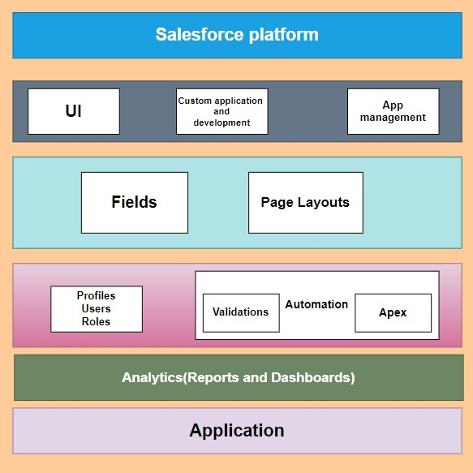

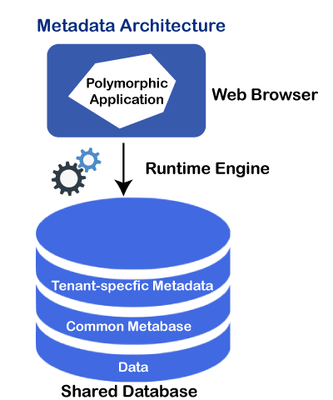

**Project Flow**

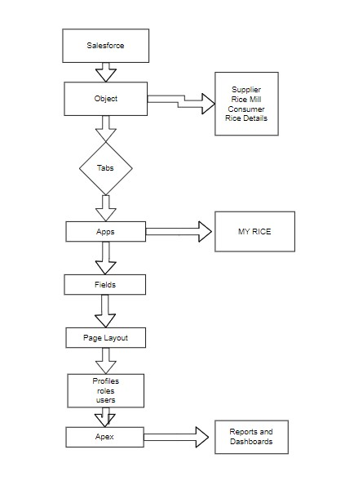

**Chapter 4 – Project Implementation Steps**

**4.1 Introduction to Salesforce**

Salesforce is your customer success platform, designed to help you sell, service, market, analyze, and connect with your customers.

Salesforce has everything you need to run your business from anywhere. Using standard products and features, you can manage relationships with prospects and customers, collaborate and engage with employees and partners, and store your data securely in the cloud.

So what does that really mean? Well, before Salesforce, your contacts, emails, follow-up tasks, and prospective deals might have been organized something like this:

<https://youtu.be/r9EX3lGde5k>

**4.1.1 Creating Developer Account**

Creating a Salesforce Developer account is the first and crucial step to accessing Salesforce’s robust development tools and environment. This account allows you to explore, build, and customize applications on the Salesforce platform. Here’s a step-by-step guide to creating and activating your Salesforce Developer account:

1. **Signing Up for a Developer Account**

To begin, you need to create a Salesforce Developer account by following these steps:

1. **Visit the Salesforce Developer Sign-Up Page:**

Navigate to https://developer.salesforce.com/signup using your web browser.

1. **Fill Out the Sign-Up Form:**

* **First Name & Last Name:** Enter your full name. This information will be used for your account.
* **Email:** Provide a valid email address. This will be used for communication and account verification purposes.
* **Role:** Select "Developer" from the dropdown menu. This ensures that the account is tailored to your development needs.
* **Company:** Enter the name of your college. This is essential as it will be part of your username
* **Country:** Choose "India" from the list of countries.
* **Postal Code:** Enter your local postal code.
* **Username:** Create a unique username. This should be a combination of your name and the company (college) name. The format typically looks like username@organization.com. Note that this username does not have to be an actual email address, so you can create any username in the mentioned format.

1. **Complete the Sign-Up Process:**

After filling in all the required details, click on the "Sign me up" button. This submits your information and triggers the account creation process.

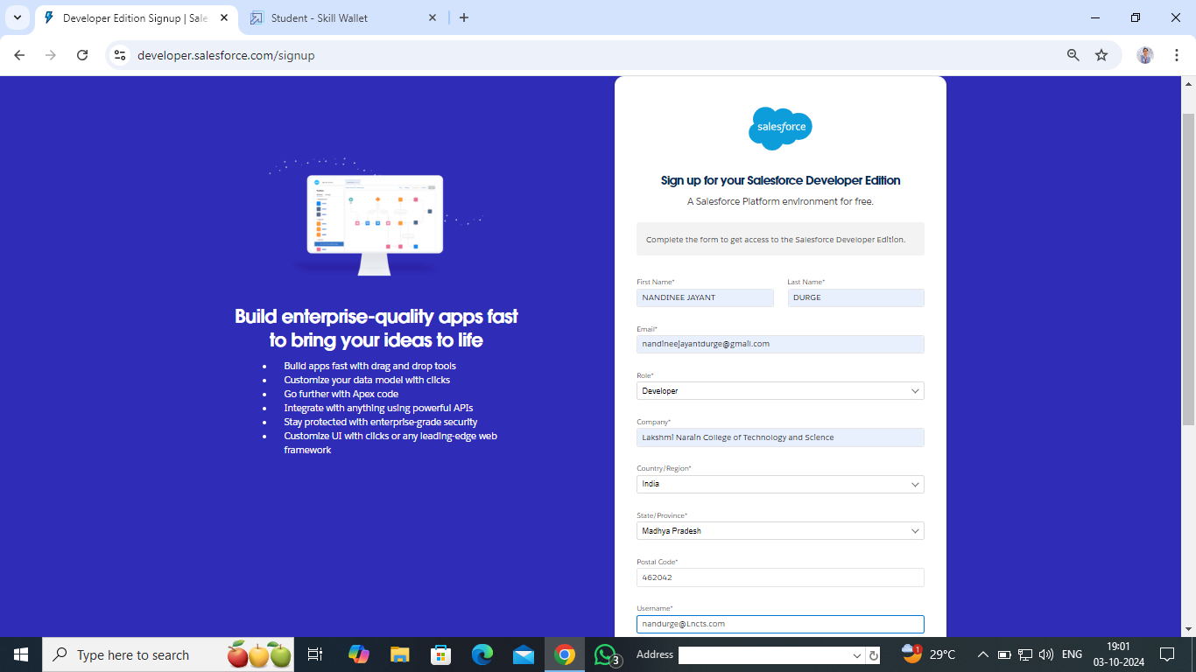

**4.1.2 Account Activation**

Once you’ve completed the sign-up form, the next step is to activate your Salesforce Developer account. Here’s how:

1. **Check Your Email for Account Verification:**

Go to the inbox of the email address you provided during sign-up. Salesforce will send you a verification email within 5-10 minutes. The subject line will typically include a message asking you to verify your account.

1. **Verify Your Account:**Open the email from Salesforce and click on the "Verify Account" link provided. This link will take you to the account activation page.
2. **Set Up Your Password:**

On the account verification page, you will be prompted to create a password. Choose a strong password that meets Salesforce’s security requirements.

You will also need to select and answer a security question. This adds an extra layer of protection to your account, allowing you to recover access in case you forget your password.

1. **Access the Salesforce Setup Page:**

After setting your password and answering the security question, click on "Change Password." You will be automatically redirected to your Salesforce setup page.

The setup page is the central hub where you can manage your Salesforce environment. From here, you can start exploring the platform, customize your org, create objects, fields, and begin developing applications.

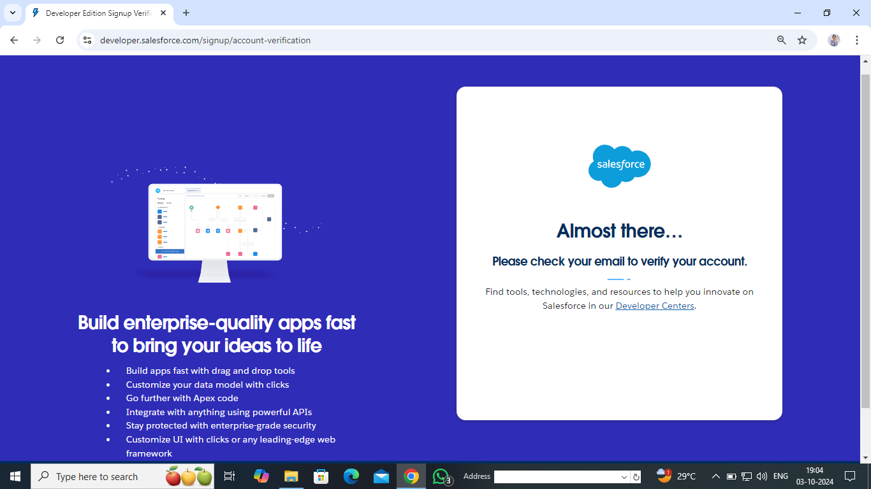

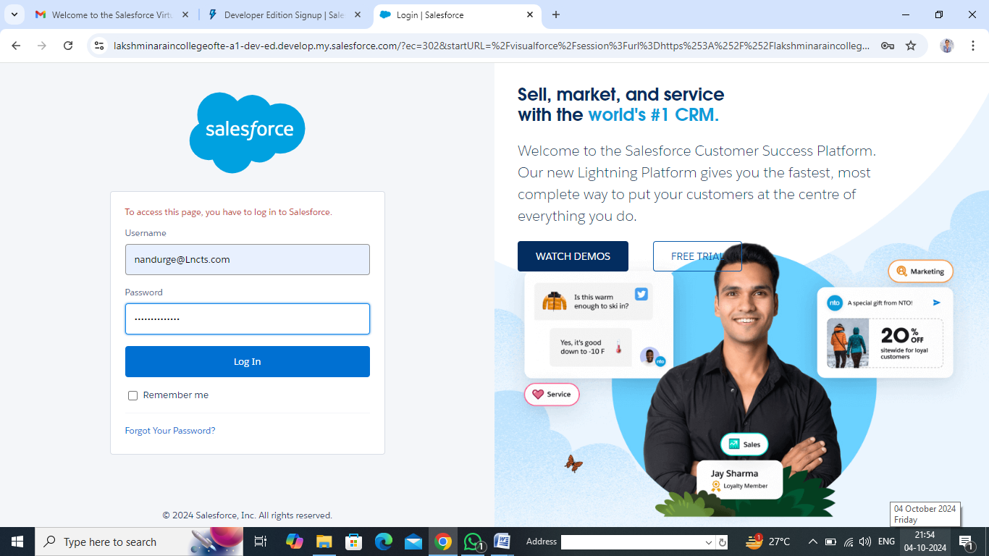

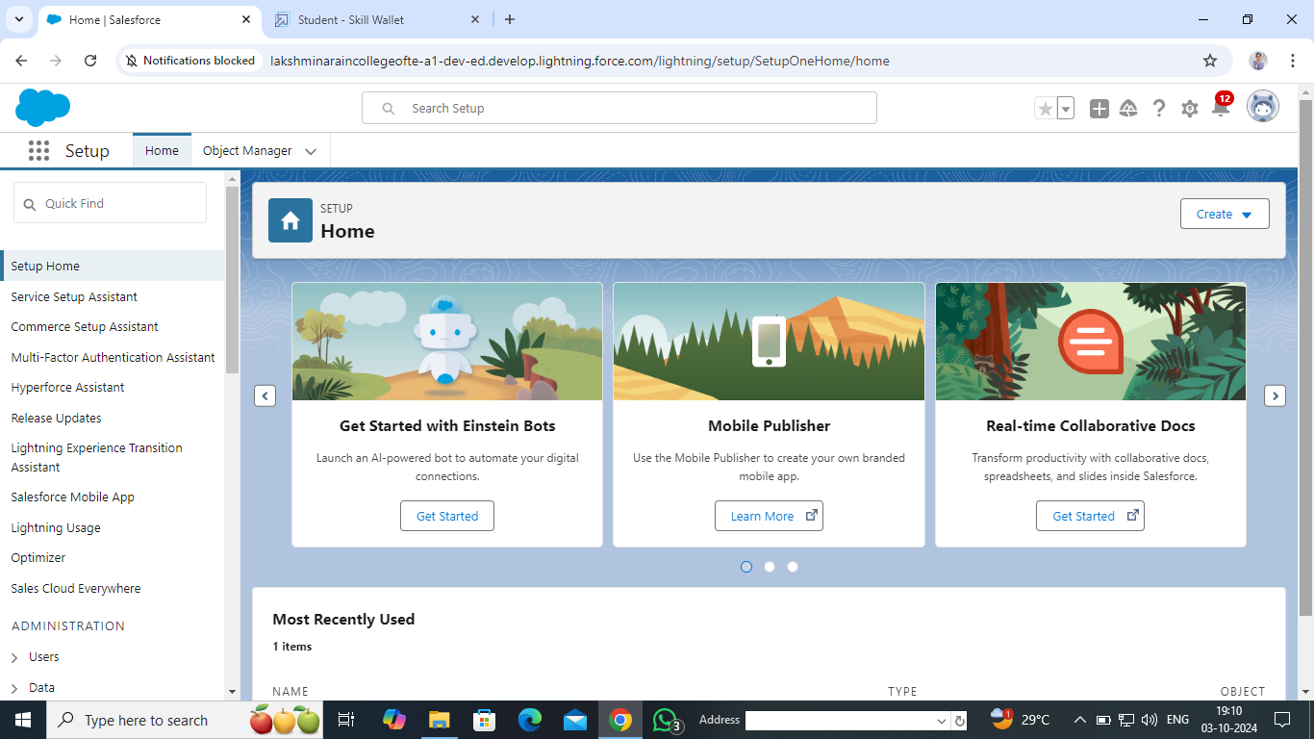

**Conclusion**

Creating and activating a Salesforce Developer account is a straightforward process that gives you access to a powerful suite of tools and features. This account is essential for anyone looking to explore Salesforce’s capabilities, whether for learning, development, or building real-world applications. Once your account is set up, you can begin customizing your Salesforce environment, working on projects, and leveraging the platform's extensive resources to enhance your skills

as a developer.

**4.2 Object:**

What Is an Object?   
Salesforce objects are database tables that permit you to store data that is specific to an organization.   
Salesforce objects serve as the fundamental building blocks of the Salesforce platform, functioning as database tables that store data specific to an organization. Understanding these objects is crucial for managing and manipulating data effectively within Salesforce.

What are the types of Salesforce Objects?  
Salesforce objects are of two types:

1. **Standard Objects:** Standard objects are the kind of objects that are provided by salesforce.com such as users, contracts, reports, dashboards, etc.  
   Standard objects are pre-defined objects provided by Salesforce that are included in every Salesforce organization.

These objects come with built-in functionality and are essential for many core features of the Salesforce platform.

**Examples**:

**Accounts:** Represents an individual account, which could be a customer, partner, or competitor.

**Contacts:** Holds information about individuals associated with an account.

**Opportunities:** Tracks sales opportunities, including the stages of a deal. **Leads:** Manages potential customers who are not yet qualified.

**Users:** Stores data about individual users who have access to Salesforce. **Contracts, Reports, Dashboards:** Used to manage agreements, generate data insights, and visualize performance metrics.

1. **Custom Objects:** Custom objects are those objects that are created by users. They supply information that is unique and essential to their organization. They are the heart of any application and provide a structure for sharing data.  
     
   Custom objects are user-defined objects created to store data unique and essential to a particular organization. They form the heart of any application on Salesforce, enabling organizations to manage and share data that doesn’t fit into the standard object.

Purpose: Custom objects are essential for tailoring Salesforce to specific business needs. For instance, in a laptop rental business, custom objects could be used to track inventory, manage customer information, or record rental transactions

To Navigate to Setup page:

1. Click on gear icon -click setup.  
   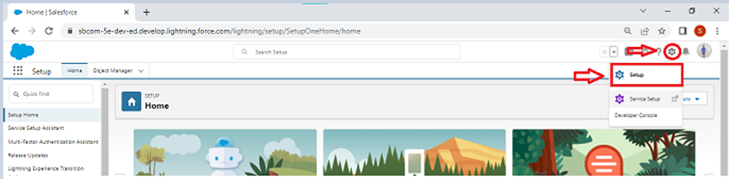

To create an object:

* 1. From the setup page - Click on Object Manager -Click on Create - Click on Custom Object.

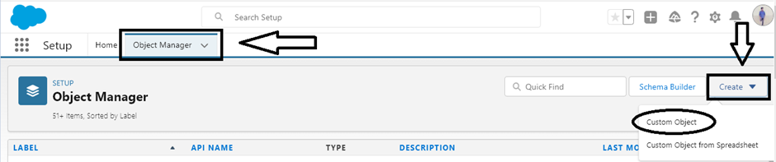

* 1. On Custom object defining page
  2. Enter the label name, plural label name, click on Allow reports, Allow search.

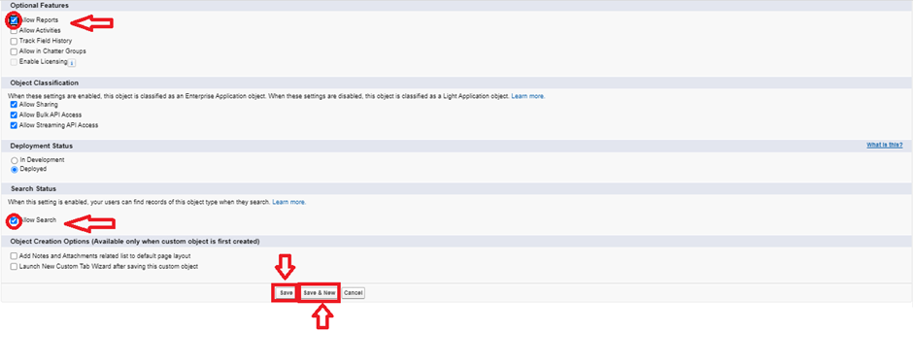

* 1. Click on Save.



**4.2.1 Create Supplier Object**

To create an object:

1. From the setup page >> Click on Object Manager>> Click on Create>>Click on Custom Object.
2. Enter the label name>>supplier
3. Plural label name>>supplier
4. Enter Record Name Label and Format

* Record Name >> supplier  Name
* Data Type>>Text

1. Click on Allow reports and Track Field History and allow search
2. Allow search >> Save.

**4.2.2 Create Rice mill Object**

To create an object:

1. From the setup page >> Click on Object Manager>>Click on Create >> Click on Custom Object.
2. Enter the label name>>rice mill
3. Plural label name>> rice mills
4. Enter Record Name Label and Format

* Record Name >>
* Data Type >> Auto Number
* Display Format >> rice-{000}
* Starting number >> 1

1. Click on Allow reports and Track Field History, Allow Search and save.

**4.2.3 Create Consumer Objects**Note: Follow the same steps as mentioned in Activity 2 for the and Receipt objects.

1. Use these display format for the  consumer

* label name >> consumer
* Plural label name >>  consumers
* Display Format >>  consumers-{000}
* Starting number >> 1

**4.2.4 Create rice details Objects**

1. Use these display format for the rice details

* label name >> rice details
* Plural label name >> rice details
* Display Format >> rice-{000}
* Starting Number >>1

**Conclusion**

Custom objects in Salesforce provide a flexible and powerful way to store and manage data that is specific to an organization's needs. Creating custom objects can effectively manage its inventory, customer data, rental transactions, and billing processes. These objects form the backbone of the CRM application, enabling the organization to streamline operations, improve customer relationships, and drive business success. As you continue to build out your Salesforce environment.

**4.3 Tabs:**

**What is Tab?**

A tab is like a user interface that is used to build records for objects and to view the records in the objects.

**Types of Tabs:**

1. **Custom Tabs:** Custom object tabs are the user interface for custom applications that you build in salesforce.com. They look and behave like standard salesforce.com tabs such as accounts, contacts, and opportunities.

Appearance: These tabs look and behave like standard Salesforce tabs and can be tailored to fit the needs of the specific custom application being developed.

1. **Web Tabs** : Web Tabs are custom tabs that display web content or applications embedded in the salesforce.com window. Web tabs make it easier for your users to quickly access content and applications they frequently use without leaving the salesforce.com application.

Usage: Commonly used to provide quick access to frequently used web resources or applications.

1. **Visualforce Tabs:** Visualforce Tabs are custom tabs that display a Visualforce page. Visualforce tabs look and behave like standard salesforce.com tabs such as accounts, contacts, and opportunities.

Appearance: Visualforce tabs appear like standard Salesforce tabs and integrate custom Visualforce pages into the Salesforce interface.

1. **Lightning Component Tabs**: Lightning Component tabs allow you to add Lightning components to the navigation menu in Lightning Experience and the mobile app.

Usage: Useful for incorporating custom Lightning components into the navigation for easy access.

1. **Lightning Page Tabs**: Lightning Page Tabs let you add Lightning Pages to the mobile app navigation menu.Lightning Page tabs don't work like other custom tabs. Once created, they don't show up on the All Tabs page when you click the Plus icon that appears to the right of your current tabs. Lightning Page tabs also don't show up in the Available Tabs list when you customize the tabs for your apps.

Usage: Ideal for organizing and accessing custom Lightning Pages within the mobile app navigation.

**4.3.1 Creating A Custom Tab(4.3.2 Creating Remaining Tabs)**

To create a Tab:

1. Go to setup page >> type Tabs in Quick Find bar >> click on tabs >> New (under custom object tab)

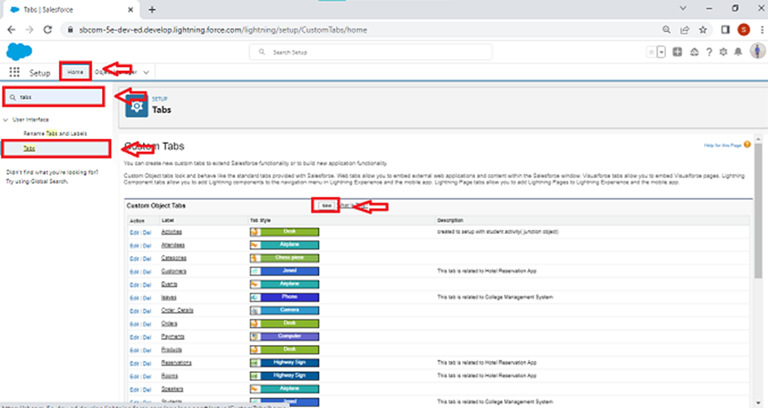

1. Select Object( supplier) >> Select the tab style >> Next (Add to profiles page) keep it as default >> Next (Add to Custom App)  uncheck the include tab .

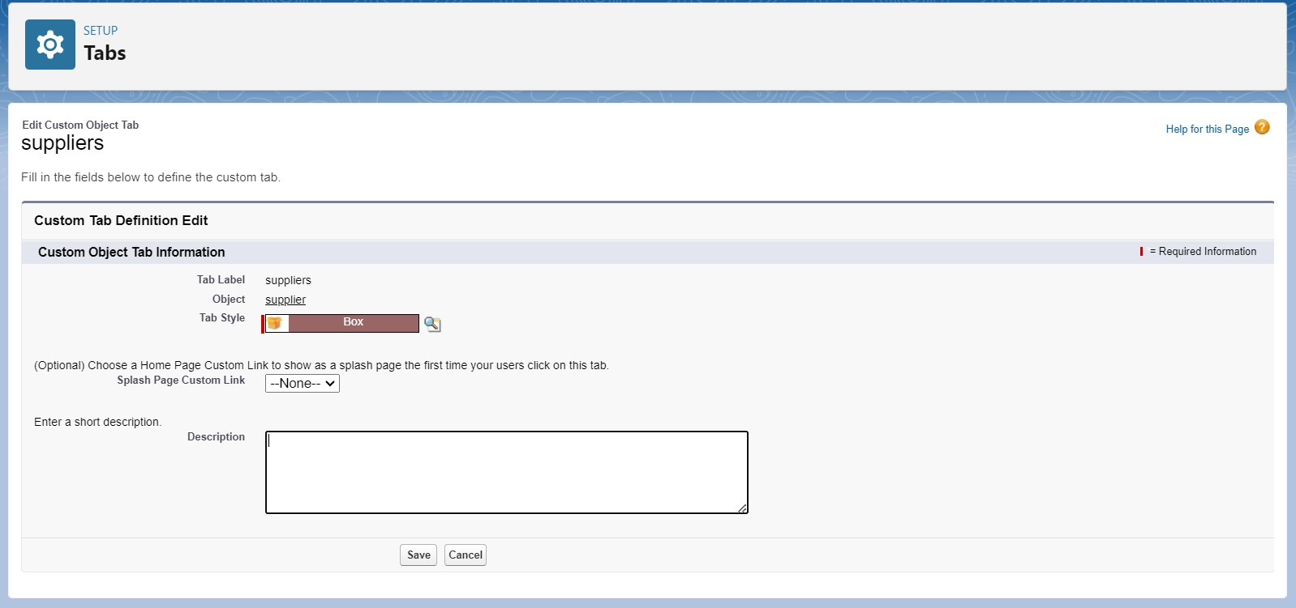

1. Make sure that the Append tab to users' existing personal customizations is checked.

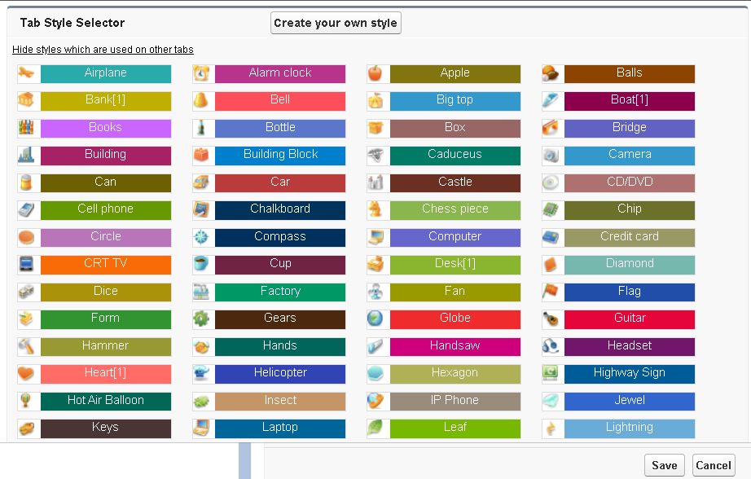

1. Click save.

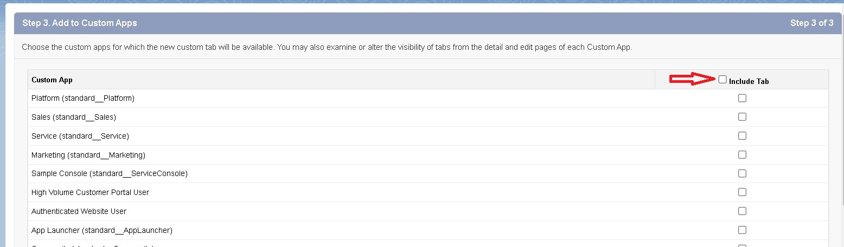

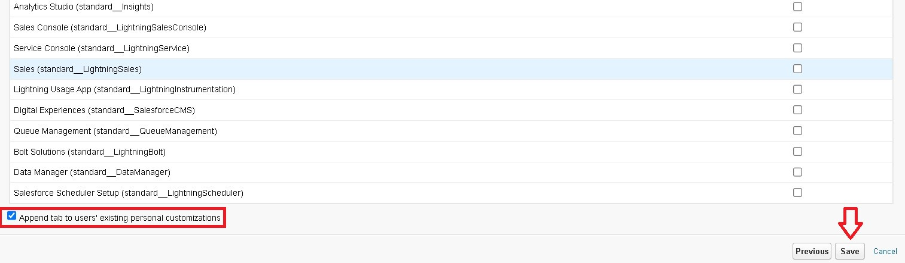

**Conclusion**

By creating these tabs, you ensure that users have easy access to the custom objects and can efficiently manage and interact with the data specific to your laptop rental CRM application. Each tab will provide a clear and intuitive interface for accessing records, enhancing the overall usability of the Salesforce platform.

**4.4 The Lightning App**

An app is a collection of items that work together to serve a particular function. In Lightning Experience, Lightning apps give your users access to sets of objects, tabs, and other items all in one convenient bundle in the navigation bar.

Lightning apps let you brand your apps with a custom color and logo. You can even include a utility bar and Lightning page tabs in your Lightning app. Members of your org can work more efficiently by easily switching between apps.

Lightning apps in Salesforce provide a streamlined way to bundle related objects, tabs, and other components into a cohesive user experience. They enable users to access all the necessary tools and information in one place, improving efficiency and organization within the Salesforce Lightning Experience. This section outlines the process for creating a Lightning app tailored to a laptop rental CRM application.

**4.4.1 Create A Lightning App**

To create a lightning app page:

1. Go to setup page >> search “app manager” in quick find >> select “app manager” >> click on New lightning App.

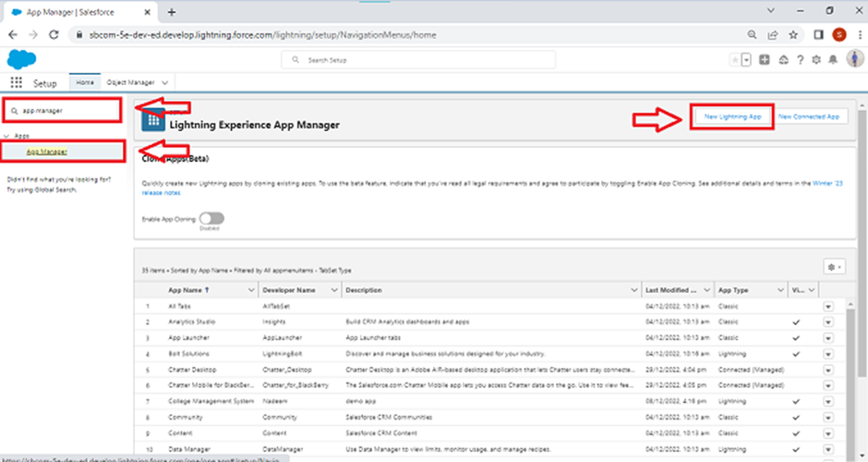

1. Fill the app name in app details as MY RICE >> Next  >> (App option page) keep it as default >> Next >> (Utility Items) keep it as default >> Next.

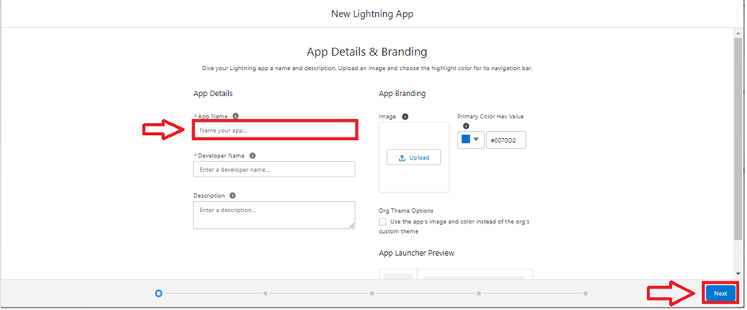

1. Upload a photo that is related to your app.
2. To add Navigation Item:

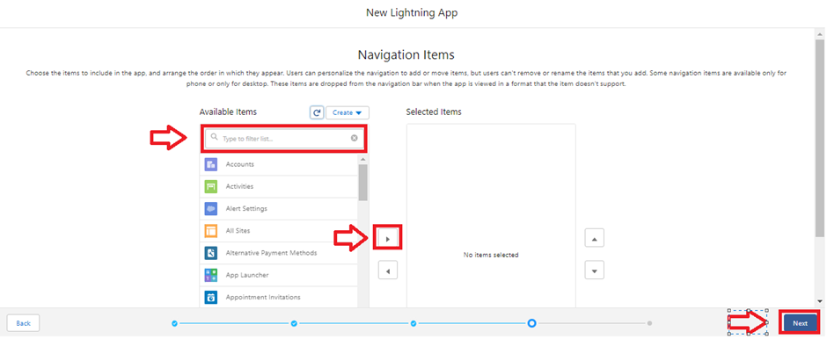

1. Select the items (supplier, rice mill, consumer , Rice details ) from the search bar and move it using the arrow button >> Next.
2. To Add User Profiles:

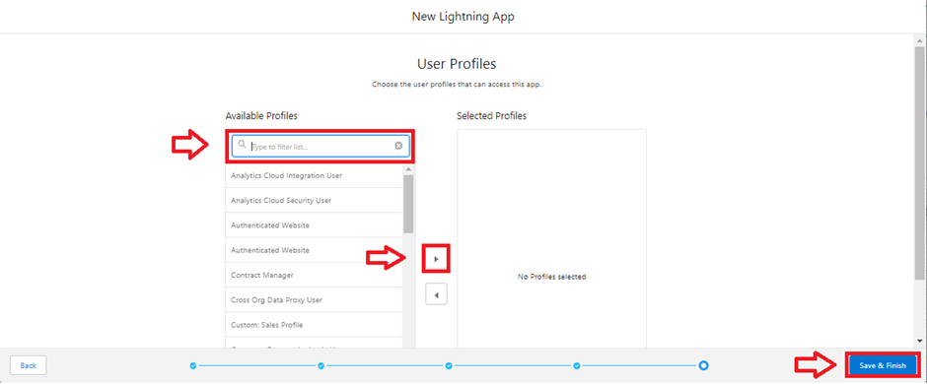

Search profiles (System administrator) in the search bar >> click on the arrow button >> save & finish.

**Conclusion**

Creating a Lightning app for your CRM allows you to tailor the Salesforce experience to meet the specific needs of your business. By bundling relevant objects, tabs, and components into a single app, you create a streamlined and efficient interface for managing your laptop rental operations. The customization options for branding, utility items, and navigation ensure that users can work effectively and access all necessary tools and information with ease. Once created, your Lightning app will be available in the Salesforce navigation bar, ready to enhance productivity and organization within your organization.

### 4.5 Fields Fields represent the data stored in the columns of a relational database. It can also hold any valuable information that you require for a specific object.

### Fields represent the data stored within objects, similar to columns in a relational database. They are crucial for capturing, organizing, and managing data effectively. Fields enable streamlined searching, deletion, and editing of records.

### Types of Fields

### Standard Fields: the Standard Fields are the predefined fields in Salesforce that perform a standard task. The main point is that you can’t simply delete a Standard Field until it is a non-required standard field. Cannot be deleted: Standard fields that are required by Salesforce cannot be deleted. Non-required standard fields can be deleted if not in use.

### Common fields: Typical examples include: o Created By: Tracks who created the record. o Owner: Indicates the record's owner. o Last Modified: Shows the last time the record was modified. o Field Made During Object Creation: Fields automatically created with the object.

### Custom Fields: Custom Fields are highly flexible, and users can change them according to requirements. Moreover, each organizer or company can use them if necessary.

### It means you need not always include them in the records, unlike Standard fields. Hence, the final decision depends on the user, and he can add/remove Custom Fields of any given form.

### Custom fields are user-defined fields that allow for greater flexibility and customization to meet specific organizational needs. Unlike standard fields, custom fields can be added, modified, or removed as needed. Users have full control over these fields, allowing them to tailor their Salesforce environment to their unique requirements.

### 4.5.1 Creating The Number Field In Rice Details Object

Creating the number field in rice details object

1. Go to the setup page >> click on object manager >> From drop down click edit for rice details object.

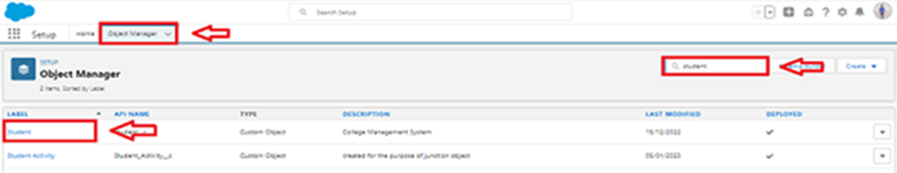

1. Click on fields & relationship >> click on New.

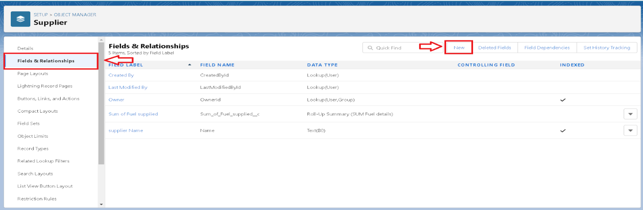

1. Select Data type as “Number” and click Next.
2. Given the Field Label as “ rice distributed ” and length as “ 5 ”.

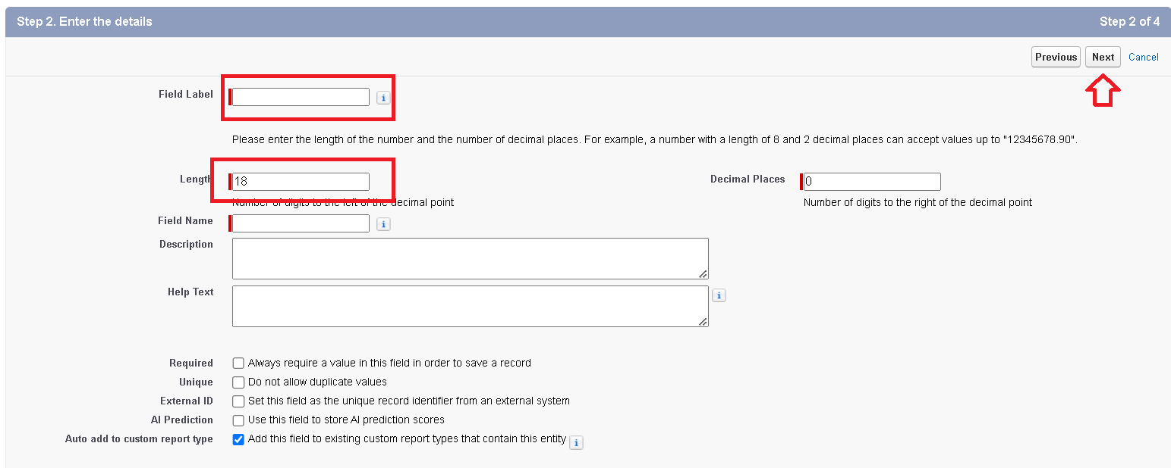

1. Field Name will be auto populated, and click on Next- Next >> Save.

### 4.5.2 Creating Junction Object

### A Junction object is a custom object that serves as a bridge between two related objects in a many-to-many relationship. It allows you to create a relationship between records of two different objects by creating a many-to-many relationship model.

Creating junction object as rice details with supplier & rice mill

To create junction object

1. Go to the setup page >> click on object manager >> From drop down click edit for rice details object.



2. Click on fields & relationship - click on New.

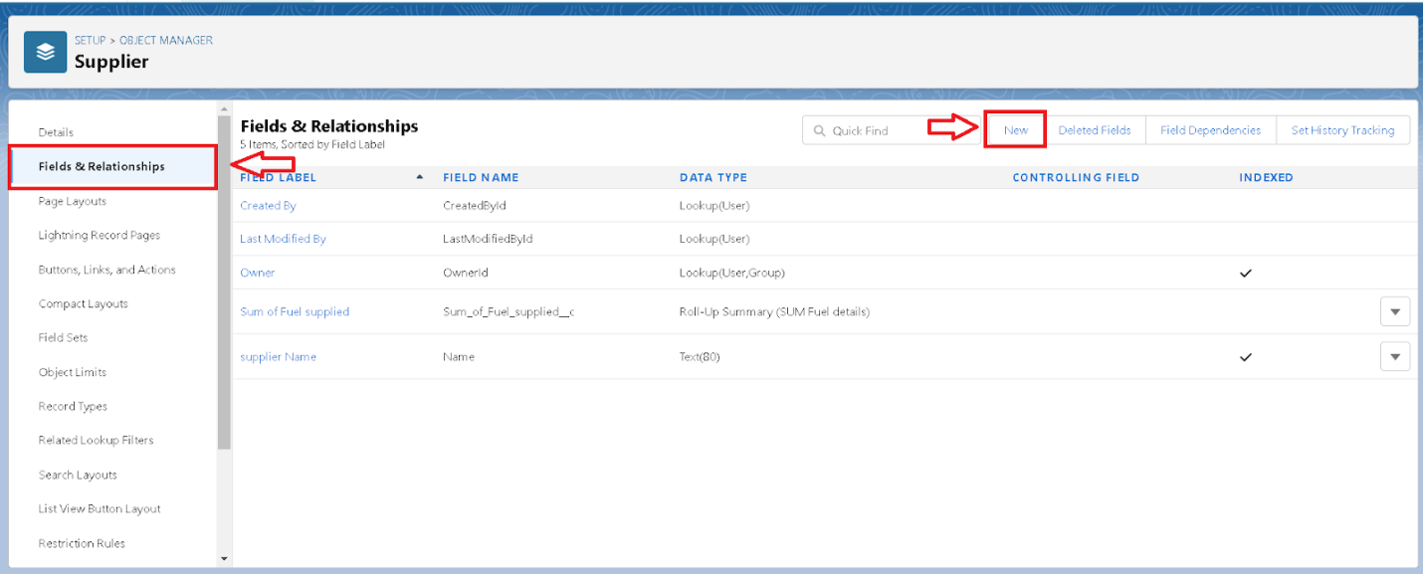

3. Select “Master-Detail relationship” as data type and click Next.

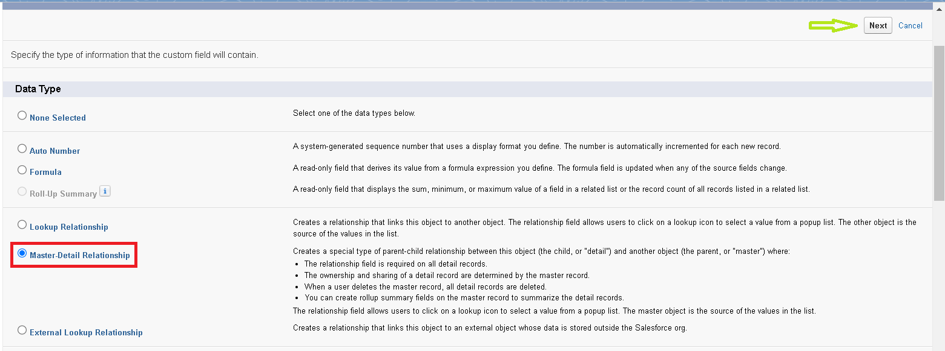

4. Select the related object “ supplier ” and click next.

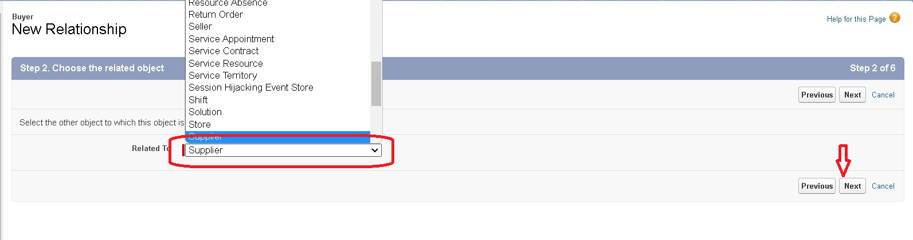

5. Give Field Label as “supplier Name” and click Next.

6. Next >> Next >> Save & New.

7. Follow the same steps from  1 to 3.

8. Select the related object “ rice mill ” and click Next.

9. Give Field Label as “rice mill 1(one)” and click Next.

10. Next >> Next >> Save.

**4.5.3 Creating A Master –Detail Relationship**

Master-detail relationship is a type of relationship between two objects where the master object controls certain behaviors and settings of the detail object. Here are a few use cases that demonstrate the use of master-detail relationships

Creating Master-Detail Relationship between consumer & rice mill Object

To Create a Master-Detail relationship

1. Go to the setup page >> click on object manager >> From drop down click edit for consumer object.
2. Click on fields & relationship >> click on New.
3. Select “Master-Detail relationship” as data type and click Next.
4. Select the related object “rice mill”.
5. Give Field Label as “rice mill name” and click Next.
6. Next >> Next >> Save.

**4.5.4 Creating The Roll-Up Summary**

A rollup summary field is a field that summarizes data from a child object to a parent object that shares a master-detail relationship. Rollup summary fields can use the COUNT, SUM, MIN, and MAX functions. For example, you could use a rollup summary field to display the total value (amount of rice supplied ) from rice  details on a related supplier.

## Creating the Roll-up summary field on supplier & rice mill Objects.

1. Go to setup >> click on Object Manager >> type object name(supplier) in search bar >> click on the object.



1. Now click on “Fields & Relationships” >> New

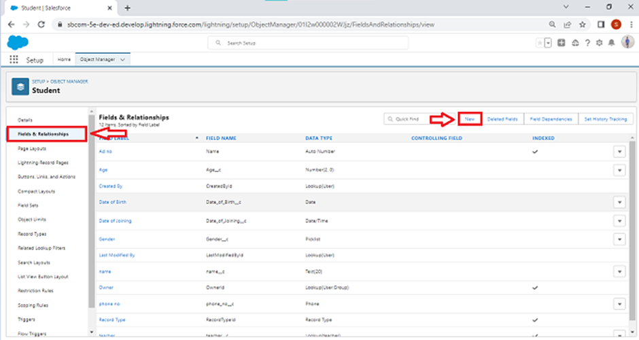

1. Select the data type as “Rollup summary”, and click Next.

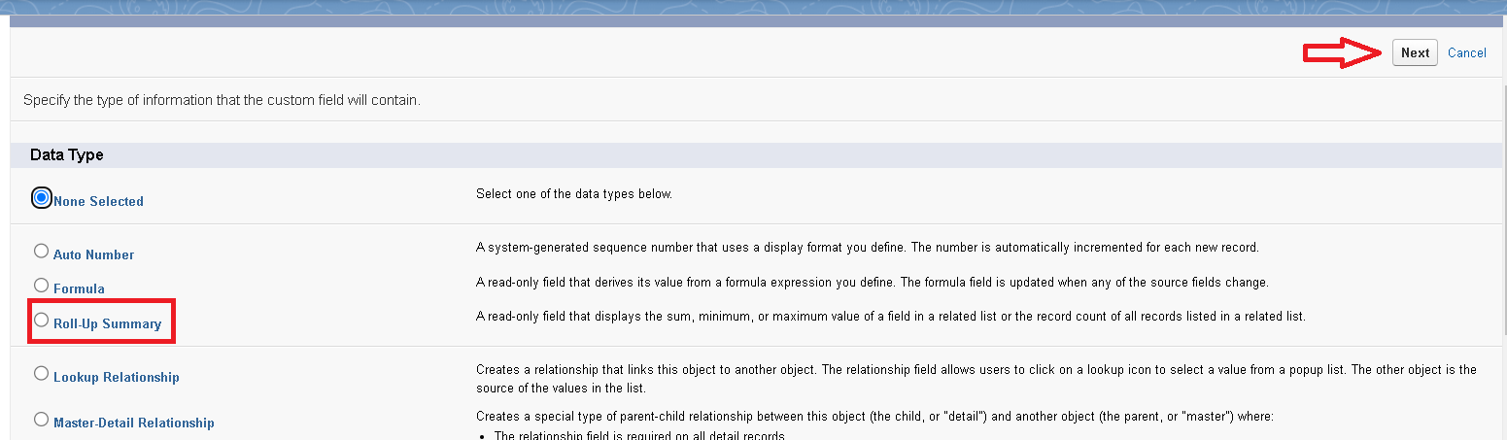

1. Give the Field label as “sum of rice distributed”, Field Name will be Auto generated, and click Next.

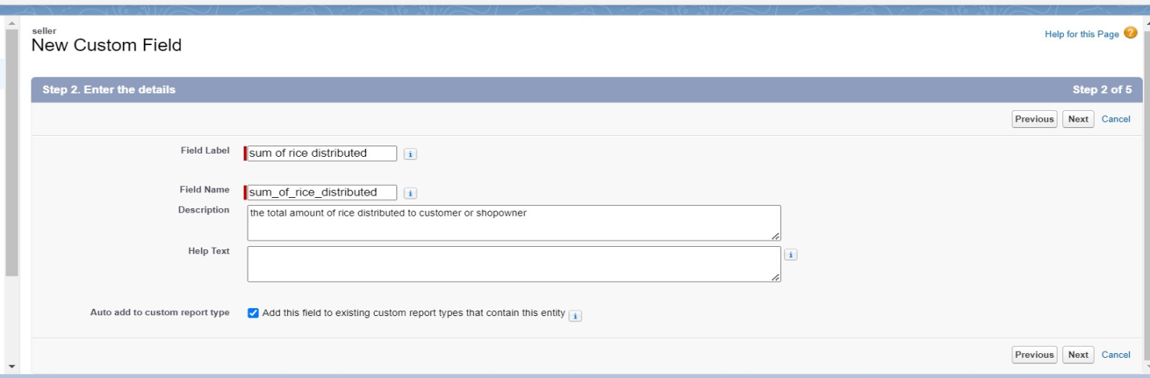

1. Select the summarized object as “rice details”.
2. Select the Rollup type as “sum”.
3. Select the field to aggregate as “rice distributed”, and click Next >>Next >>Save.

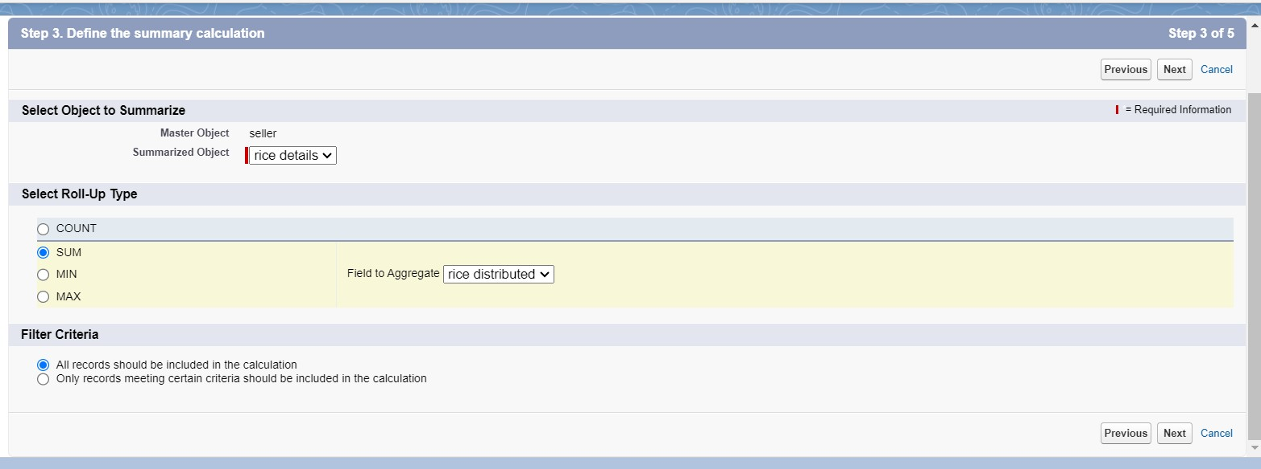

1. Follow the same steps for the rice mill Object from 1 to 3
2. Give the Field label as “rice distributed to shops”, Field Name will be Auto generated, and click Next.
3. Select the summarized object as “rice details”.
4. Select the Rollup type as “sum”.
5. Select the field to aggregate as “rice distributed”, and click Next >> Next >> Save.
6. Note : create the field as  “ rice taken by shops in kgs”  using number datatype in consumer object
7. Follow the same steps for the rice mill Object from 1 to 3
8. Give the Field label as “ rice taken ”,Field Name will be Auto generated, and click Next.
9. Select the summarized object as “consumer”.
10. Select the Rollup type as “sum”.
11. Select the field to aggregate as “rice taken in shops”, and click Next >> Next >> Save.

**4.5.5 Creating Fields In Objects**

Creating the number field in rice details object

1. Go to the setup page >> click on object manager >> From drop down click edit for rice details object.
2. Click on fields & relationship >> click on New.

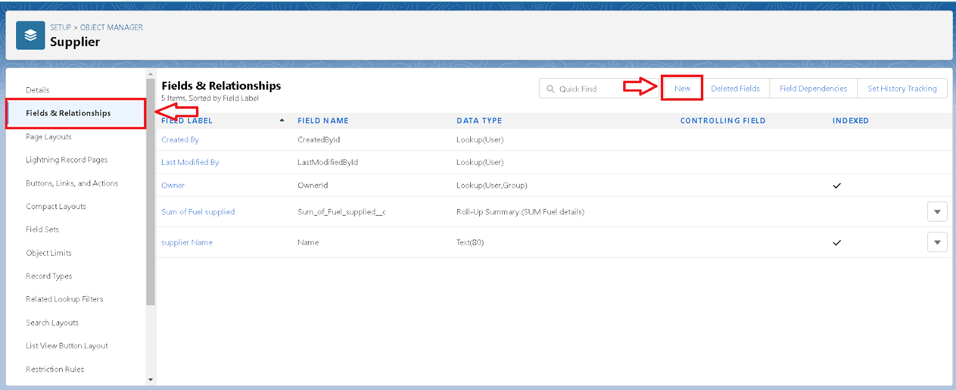

1. Select Data type as “master detail” and click Next.
2. Given the Field Label as “ supplier  name ” and length as “ 5



1. Field Name will be auto populated, and click on Next>> Next >>Save.

**4.5.6 Creating Fields In Rice Mill Objects**

1. Select Data type as “Number” and click Next.
2. Given the Field Label as “ rice price/kg ” and length as “ 5 ”

**4.5.7 Creating Fields In Consumer Objects**

**Object Name – consumer**

|  |  |  |
| --- | --- | --- |
| **S.NO.** | **FIELDS** | **DATA TYPE** |
| 1. | First name | Text |
| 2. | Last name | Text |
| 3. | Phone number | phone |
| 4. | email | Email |
| 5. | Rice type | Number(length=5) |
| 6. | Mode of payment | Picklist values  1.Credit card  2.Debit card  3.Net banking  4.UPI  5.Cash |

**4.5.8 Creating Cross Object Formula Field In Consumer Object**

A cross-object formula field is a formula field that references fields from another object in Salesforce. This type of formula allows users to calculate and display data from multiple objects on a single record.

Note: check whether the fields mentioned in the formula field are created or not , if not go to activity 9 and create those fields mentioned in consumer object.

1. Go to setup >> click on Object Manager >> type object name (consumer) in search bar >> click on the object.
2. Click on fields & relationship >> click on New.
3. Select Data type as “Formula” and click Next.
4. Give Field Label and Field Name as “Amount Paid” and select formula return type as “Number” and click next.

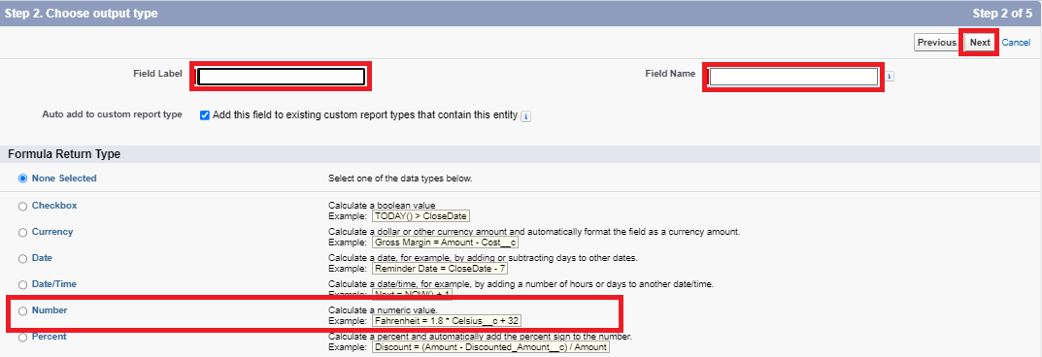

1. Insert fields formula should be :

  rice_taken_by_shops__c  * rice_mill_name__r.rice_price_kg__c

1. Under Advanced Formula write down the formula and click “Check Syntax” and Save.

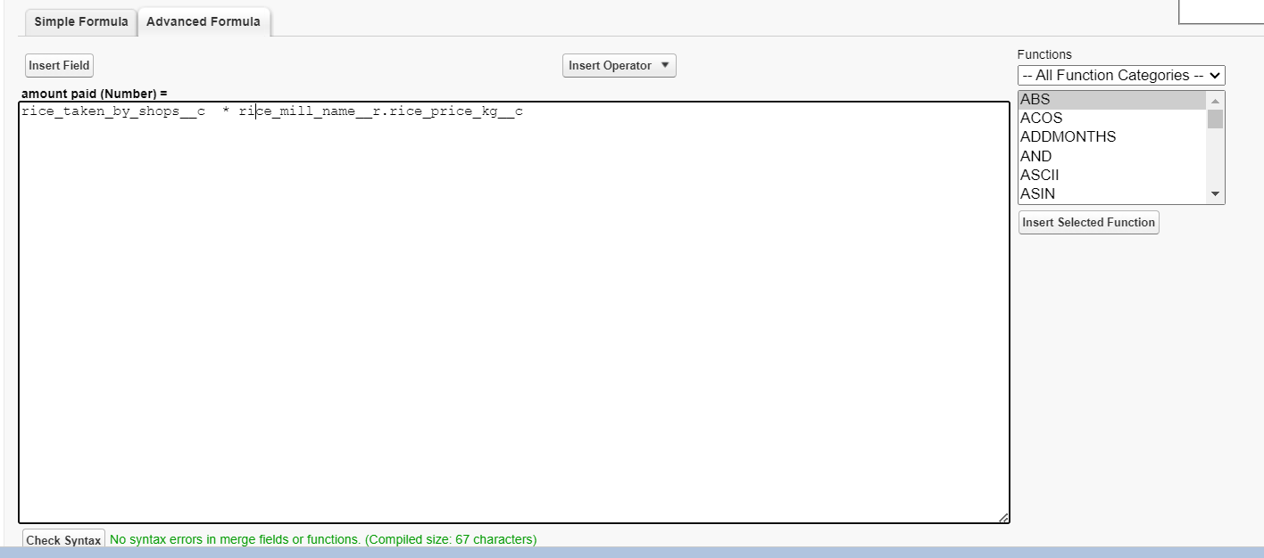

1. Creating the Formula field in consumer Object

Note: check whether that the fields that mentioned in the formula field are created are not , if not go to activity 9 and create that fields mentioned in consumer object

1. Go to setup >> click on Object Manager >> type object name(consumer) in search bar >> click on the object.
2. Click on fields & relationship >> click on New.
3. Select Data type as “Formula” and click Next.
4. Give Field Label and Field Name as “Consumer Name” and select formula return type as “TEXT” and click next.
5. Insert field formula should be : First_Name__c   + ' ' +  Last_Name__c
6. click “Check Syntax” and Save.



**4.5.9 Creating The Validation Rule**

Improve the quality of your data using validation rules. Validation rules verify that the data a user enters in a record meets the standards you specify before the user can save the record.

A validation rule can contain a formula or expression that evaluates the data in one or more fields and returns a value of “True” or “False”.

Validation rules also include an error message to display to the user when the rule returns a value of “True” due to an invalid value.

Creating the validation rule for phone number field in consumer  object

Note : check whether the fields mentioned in the formula field are created or not , if not go to activity 9 and create those fields mentioned in consumer object.

1. Go to the setup page >>click on object manager >> From drop down click edit for  consumer object.
2. Click on the validation rule >> click New.

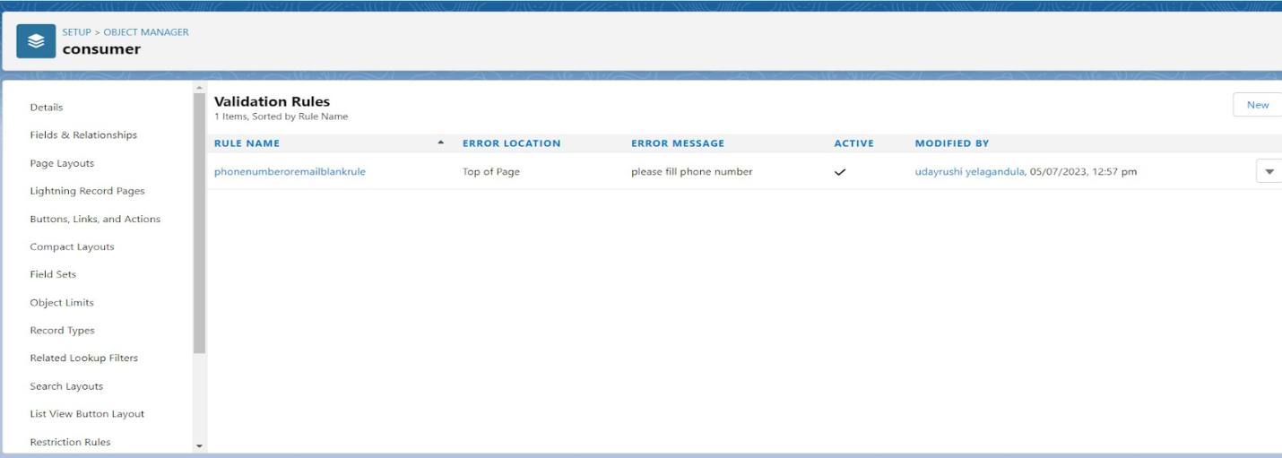

1. Enter the Rule name as “Phonenumberoremailblankrule ”.
2. Enter the description as “phone number and email number should not be blank”.
3. Enter the formula as “OR( ISBLANK( phone_number__c ) , ISBLANK( email__c ) )” and check the syntax.

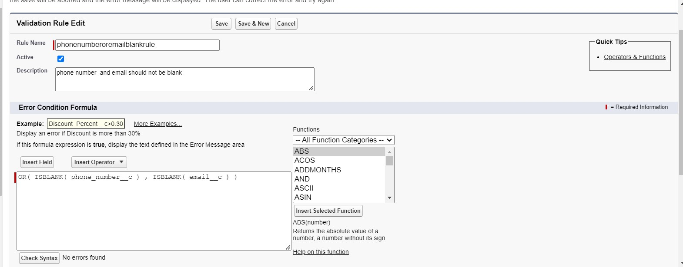

1. Under the error message write as”please fill in your phone number.”
2. Select error location “top of page”.
3. Save the validation rule.

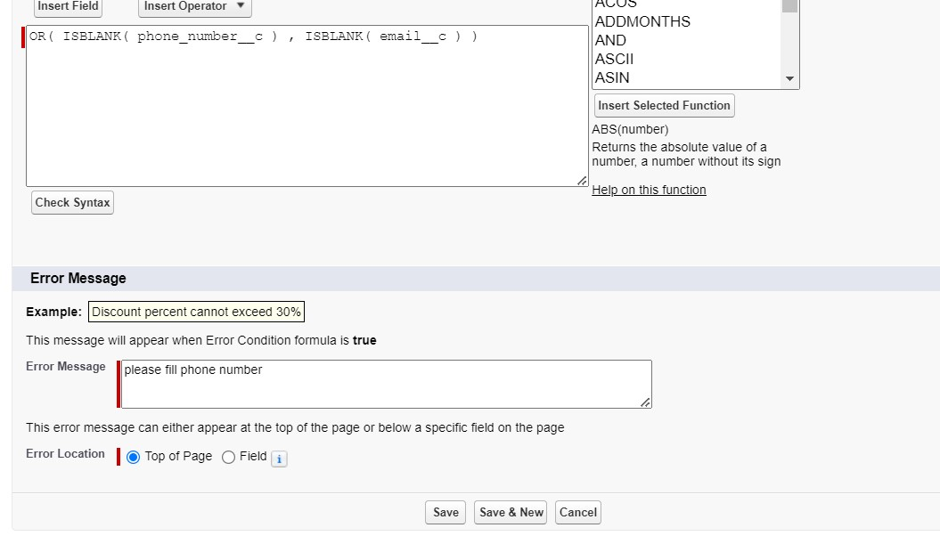

**4.6 Page layouts**

Page Layout in Salesforce allows us to customize the design and organize detail and edit pages of records in Salesforce.

Page layouts can be used to control the appearance of fields, related lists, and

custom links on standard and custom objects' detail and edit pages.

**4.6.1 Creating The Page Layout**

To Create a Page layout:

1. Go to Setup >> Click on Object Manager >>Search for the object (consumer) >> From drop down select the object and click on it.
2. Click on Page layout >> Click on New.

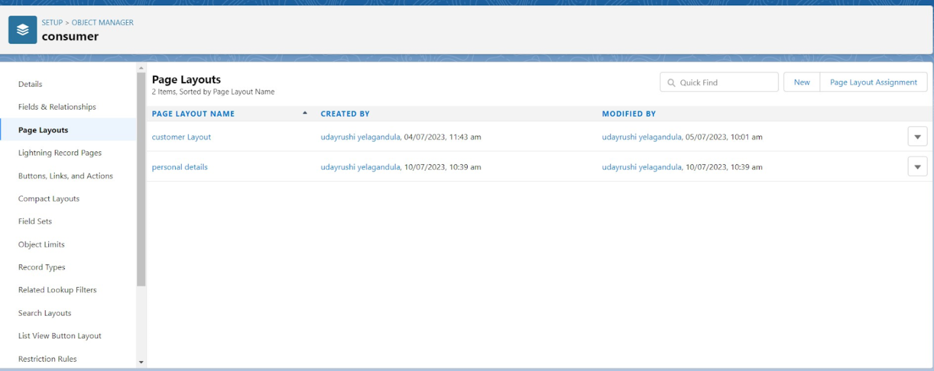

1. Select the existing page layout, and give the page layout name as “consumer layout”, and click save.

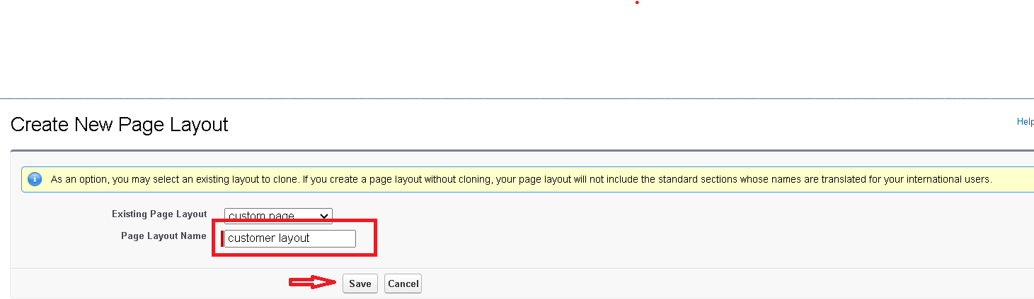

1. Drag and drop the section field to consumer details and create the section.
2. Enter the section name as “Personal details”, - click Ok.

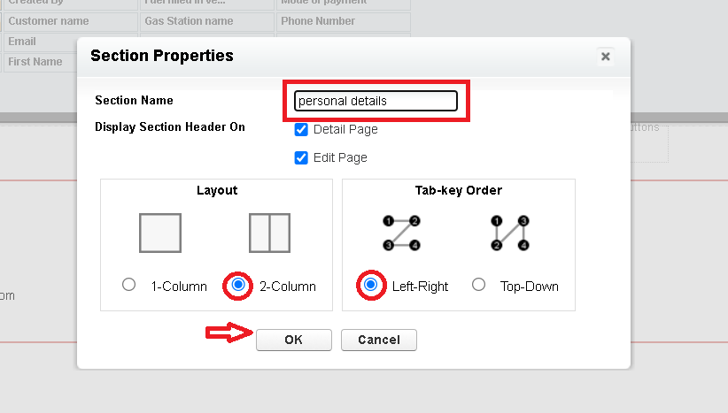

1. Now drag the fields to this section that mentioned , they are

* First name , last name , consumer name , phone number, email, rice mill name.

1. Follow the same process for another two sections as shown above , they are
2. One section is “ rice details ” , drag the fields that are

* Rice taken by shop, rice type.

1. Another section is “Receipt details ”, and drag the fields that are

* Mode of payment , Amount paid.

1. Then , Click save.

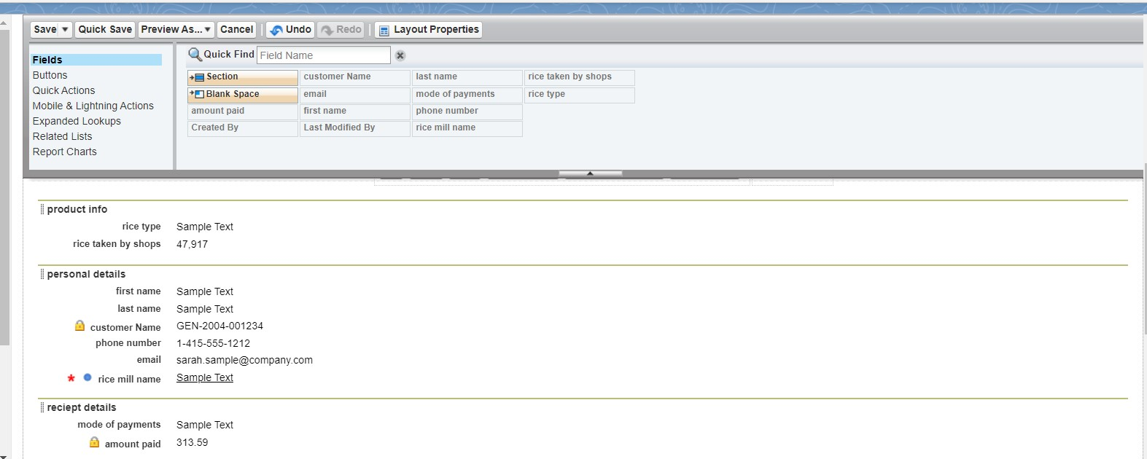

**4.7 Profiles**

A profile is a group/collection of settings and permissions that define what a user can do in salesforce. Profile controls “Object permissions, Field permissions, User permissions, Tab settings, App settings, Apex class access, Visualforce page access, Page layouts, Record Types, Login hours & Login IP ranges.

**You can define profiles by the user's job function. For example System Administrator, Developer, Sales Representative.**

Types of profiles in salesforce

1. **Standard profiles:**By default salesforce provides below standard profiles.

* Contract Manager
* Read Only
* Marketing User
* Solutions Manager
* Standard User
* System Administrator.

We cannot delete standard ones

Each of these standard ones includes a default set of permissions for all of the standard objects available on the platform.

1. **Custom Profiles:** Custom ones defined by us. They can be deleted if there are no users assigned with that particular one.

**4.7.1 Owner Profile**

To create a new profile:

1. Go to setup >> type profiles in quick find box >> click on profiles >> clone the desired profile (Standard User) >>enter profile name (owner) >> Save.

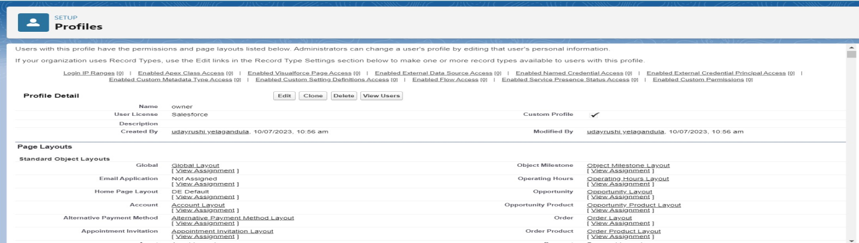

1. Scroll down to Custom Object Permissions and Give access permissions for consumers, rice details , rice mill and suppliers objects as mentioned in the below diagram.

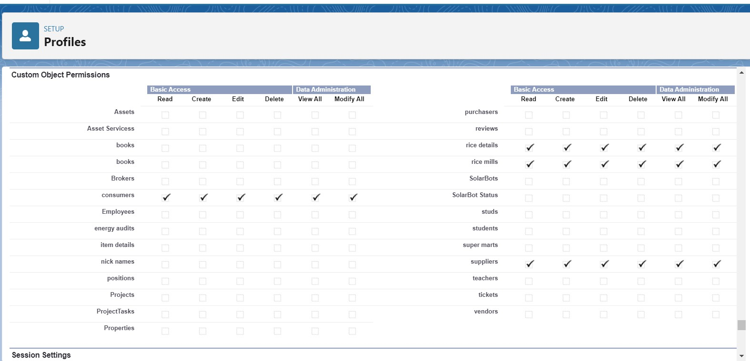

1. Give access and save it.

**4.7.2 Employer Profile**

To create a new profile:

1. Go to setup >> type profiles in quick find box >> click on profiles >> clone the desired profile (Standard User) >>enter profile name (owner) >> Save.
2. While still on the profile page, then click Edit.
3. Scroll down to Custom Object Permissions and Give access permissions for consumers, rice details , rice mill and suppliers objects as mentioned in the below diagram.
4. Scroll down to Custom Object Permissions and Give access permissions for consumer, rice details , rice mill  and suppliers  objects as mentioned in the below diagram.
5. Give access and save it.

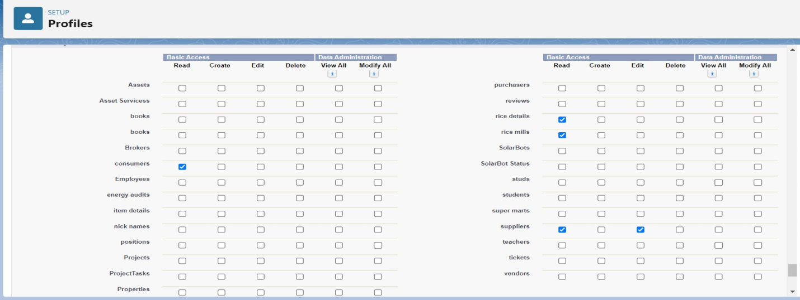

**4.7.3 Worker Profile**

1. Go to setup >> type profiles in quick find box >> click on profiles >> clone the desired profile (Standard Platform User) >> enter profile name (worker) >> Save.
2. While still on the profile page, then click Edit.
3. Select the Custom App settings as default for the rice mill.
4. Scroll down to Custom Object Permissions and Give access permissions for consumer, rice details , rice mill  and suppliers objects as mentioned in the below diagram.

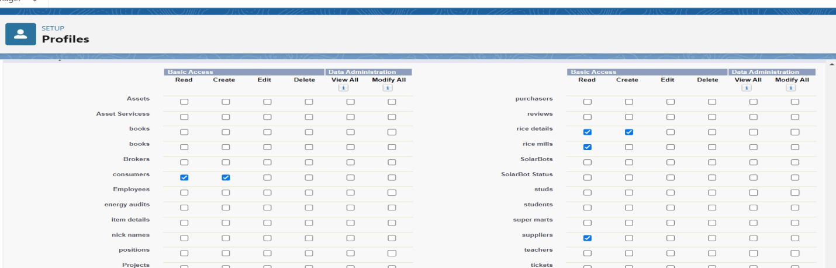

1. And click save.

**Conclusion**   
This process ensures that users with different roles have the appropriate permissions to access and interact with the necessary objects and functionalities in Salesforce.

### 4.8 Role & Role Hierarchy

A role in Salesforce defines a user's visibility access at the record level. Roles may be used to specify the types of access that people in your Salesforce organization can have to data. Simply put, it describes what a user could see within the Salesforce organization.

**4.8.1 Creating Owner Role**

Creating owner Role:

1. Go to quick find >> Search for Roles >> click on set up roles.
2. Go to quick find >> Search for Roles >> click on set up roles.

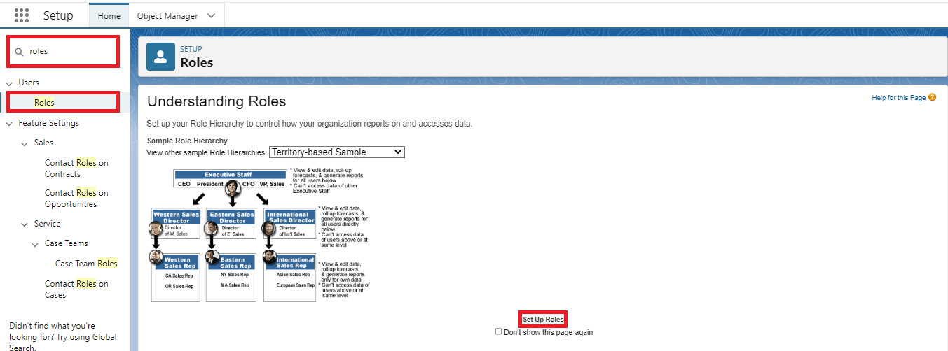

1. Click on Expand All and click on add role under which this role works.

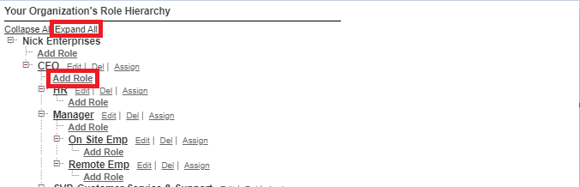

1. Give Label as “owner” and Role name gets auto populated. Then click on Save.

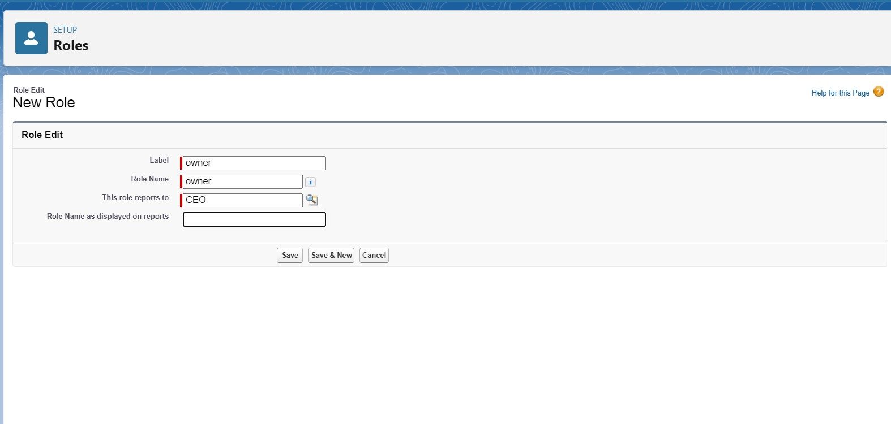  
5. Click and save it.

**4.8.2 Creating Employer Roles**

Creating another two roles under manager

1. Go to quick find >>Search for Roles >>click on set up roles.
2. Click plus on CEO role, and click add role under owner.

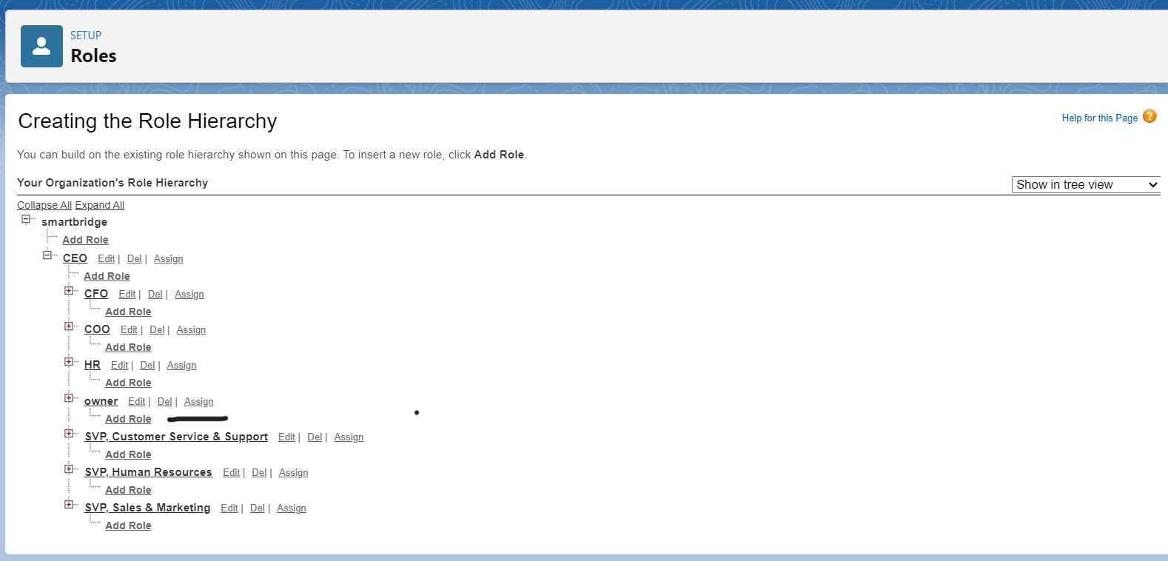

1. Give Label as “employer” and Role name gets auto populated. Then click on Save.
2. Repeat the same steps, for another role.
3. Click plus on CEO role and click plus on owner, and click add role under employer.

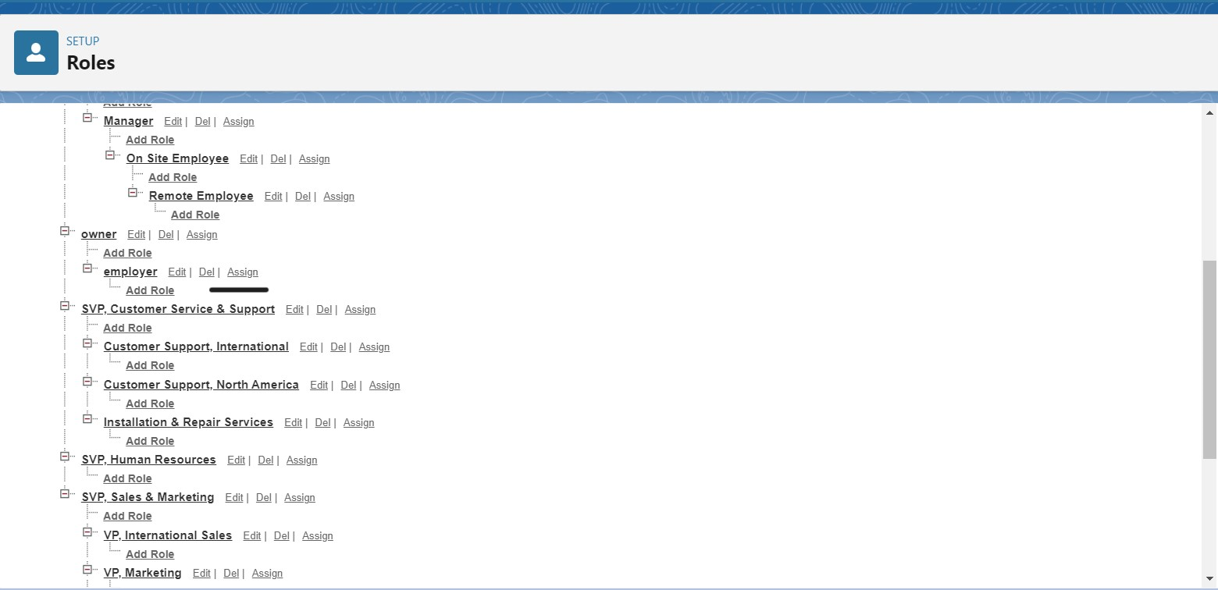

1. Give Label as “worker” and Role name gets auto populated. Then click on Save.

### Conclusion: This setup allows you to define the hierarchy within your Salesforce organization, ensuring that users have the appropriate level of access based on their role.

### 4.9 Users

A user is anyone who logs in to Salesforce. Users are employees at your company, such as sales reps, managers, and IT specialists, who need access to the company's records. Every user in Salesforce has a user account. The user account identifies the user, and the user account settings determine what features and records the user can access.

**4.9.1 Create User**

1. Go to setup >> type users in quick find box >> select users >> click New user.
2. Fill in the fields
3. First Name : vicky
4. Last Name : y
5. Alias : Give a Alias Name
6. Email id : Give your Personal Email id
7. Username : Username should be in this form: text@text.text
8. Nick Name : Give a Nickname
9. Role : owner

10.Profiles : owner.

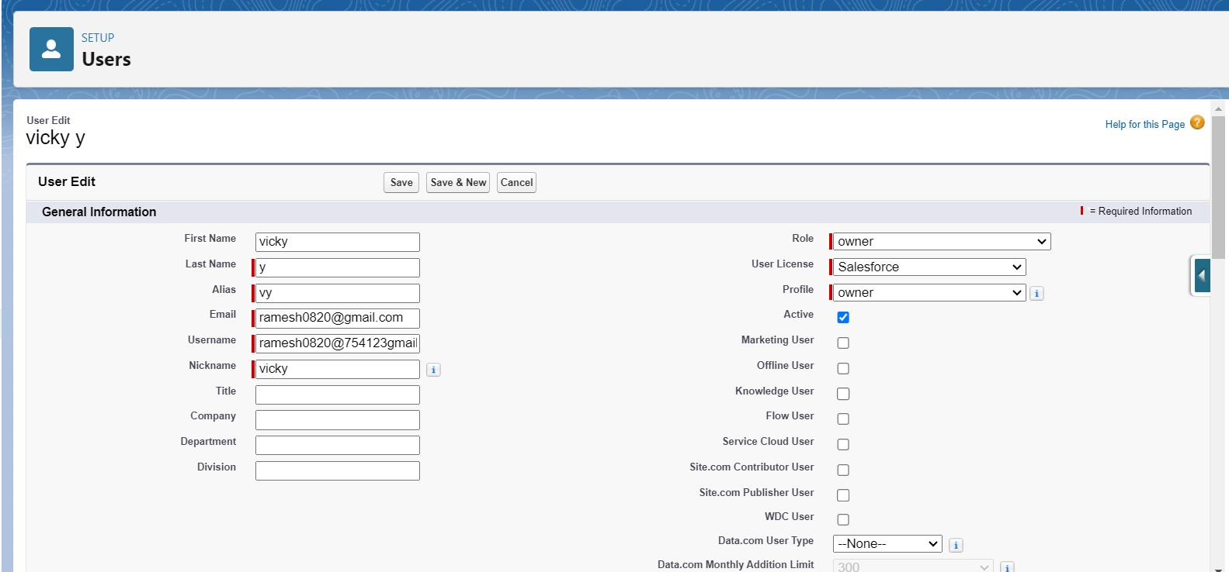

11.Save it.

**4.9.2 Creating Nother Users**

1. Go to setup ? type users in quick find box ? select users ? click New user.
2. Fill in the fields
3. First Name : ram
4. Last Name : ram
5. Alias : Give a Alias Name
6. Email id : Give your Personal Email id
7. Username : Username should be in this form: text@text.text
8. Nick Name : Give a Nickname
9. Role : employer
10. User license : Salesforce platform
11. Profiles : standard platform user.

**4.9.3 Creating Another User**

1. Go to setup ? type users in quick find box ? select users ? click New user.
2. Fill in the fields
3. First Name : ragu
4. Last Name : raj
5. Alias : Give a Alias Name
6. Email id : Give your Personal Email id
7. Username : Username should be in this form: text@text.text
8. Nick Name : Give a Nickname
9. Role : worker
10. User license : Salesforce platform
11. Profiles : standard platform user.

**Conclusion**  
By creating users and assigning them appropriate roles, licenses, and profiles, you can control what each individual can access and manage within your Salesforce environment.

**4.10 Permission Set**

A permission set is a collection of settings and permissions that give users access to various tools and functions. Permission sets extend users’ functional access without changing their profiles and are the recommended way to manage your users’ permissions.

Sharing rules are used to extend access to records to users in public groups or roles. They allow administrators to define additional criteria for sharing records beyond what is granted by default through profiles and roles, ensuring appropriate data access across the organization.

* + 1. **Creating OWD Setting**

1. Go to setup >> type “sharing settings ” in quick search >> Click edit.

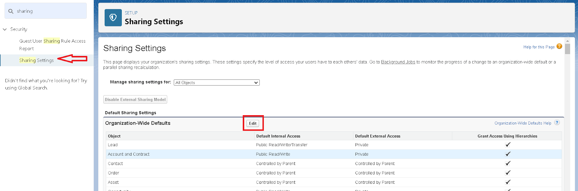

1. Scroll down, change the default internal access to “ public read-only” for rice mill and supplier  object.
2. Click save.
3. Extra information, By these every profile has their own access, according to their profile.
4. But in our case we created roles and given the roles in such a way that the owner  can see   employer  and worker  records , and the employer can see the worker  records.

**4.11 Report**

Report types define the set of records and fields available for a report. They determine which objects, and their relationships can be included, allowing users to create customized reports based on specific criteria.

Reports in Salesforce provide a way to analyze and visualize your data. They come in various formats, each suited to different types of analysis. Here's an overview of the types of reports you can create in Salesforce:

**Types of Reports in Salesforce**

**1. Tabular Reports  
Description:** Provides a simple list of data without any subtotals.  
**Use Case**: Ideal for generating straightforward lists or simple data tables.   
**Example**: A report listing all accounts, contacts, or opportunities.

**2. Summary Reports**   
**Description:** Offers data with groupings and subtotals.   
**Use Case:** Useful for reports that need to show subtotals based on a particular field, or to organize data hierarchically **Example:** A report showing all opportunities grouped and subtotaled by Sales Stage and Owner.

**3. Matrix Reports  
Description:** Allows data to be grouped by both rows and columns, providing a comparison of totals across two dimensions.  
**Use Case**: Best for complex data analysis where you need to view data by multiple dimensions.  
**Example:** A report summarizing opportunities by month (rows) and by account (columns).

**4. Joined Reports**   
**Description:** Combines multiple report blocks into a single report, each block with unique columns, summaries, formulas, and filters.  
**Use Case:** Suitable for showing related data from different report types or objects in a single view.   
**Example:** A report combining opportunity, case, and activity data for your accounts

**4.11.1 Create Report**

Note: Before creating a report, create the latest “10” records in consumer  objects.

Try to fill every field in each record for better experience.

1. Go to the app >>click on the reports tab
2. Click New Report.

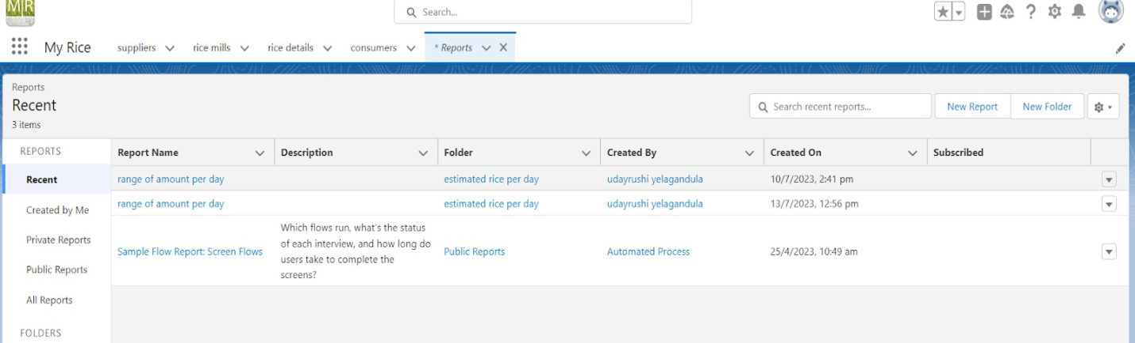

1. Select for report type, search for “rice mill with consumers” click on it. And click on start report.

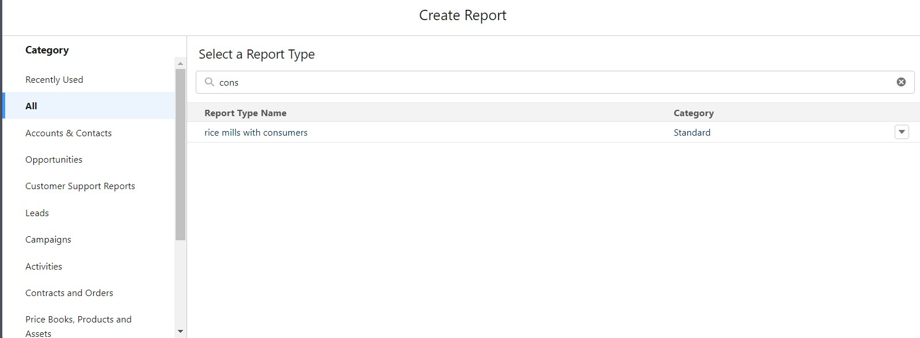

1. Their outline pane is opened already; select the fields that are mentioned below in the column section.

           1. consumer name

           2. rice type

           3. rice price/kg

           4. mode of payments

           5. amount paid

1. Remove the unnecessary fields.
2. Select the fields that are mentioned below in the GROUP ROWS section.
   1. Rice taken by shops

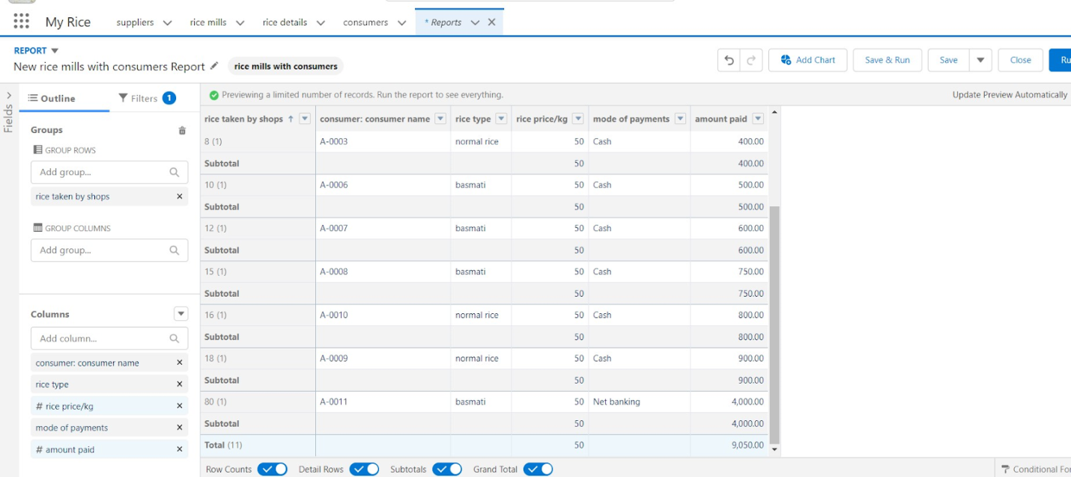  
Click save and run and save the report as “range of amount per day”. and save it.

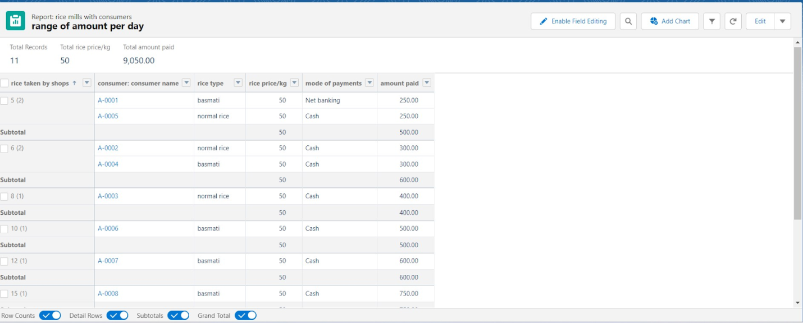 **4.11.2 Sharing Report To Owner**

1. Click edit drop down and select subscribe option

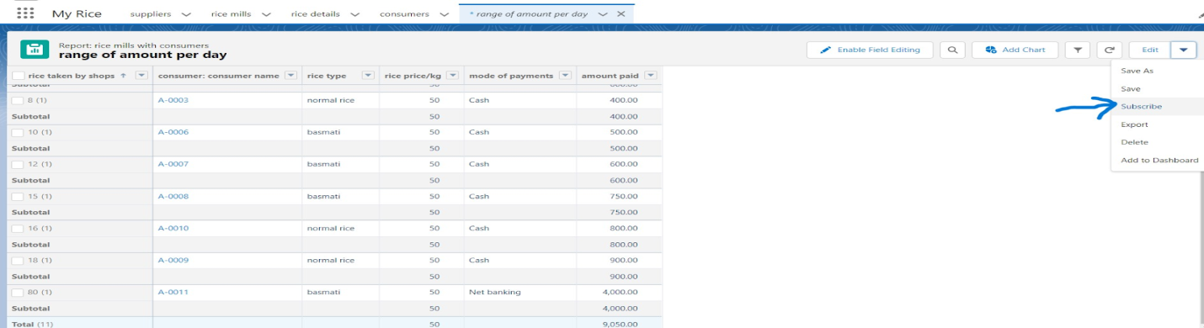

1. Follow as per below image.

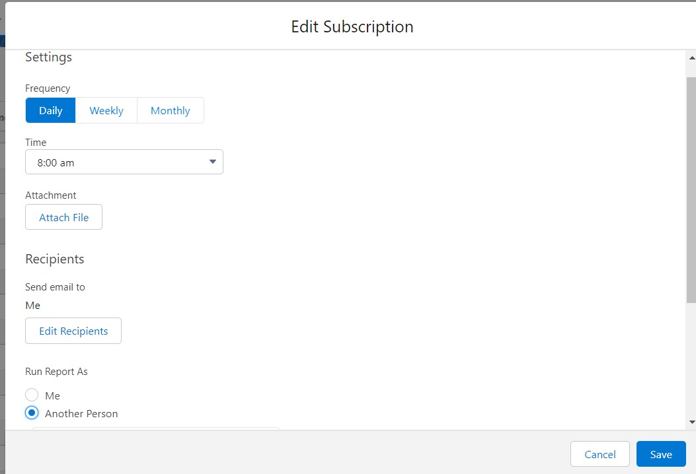

1. After selecting the run report as a “another person”  select your personal account or whom you want to send that mail to.
2. Click save.

NOTE: The owner gets daily email notification of that rice mill report.so that he can see all data remotely.

**4.11.3 Create A Report Folder**

1. Click on the app launcher and search for reports.
2. Double click on the report, “reports tab” will be auto populated in the navigation bar.
3. Click on the report tab, click on the new folder.

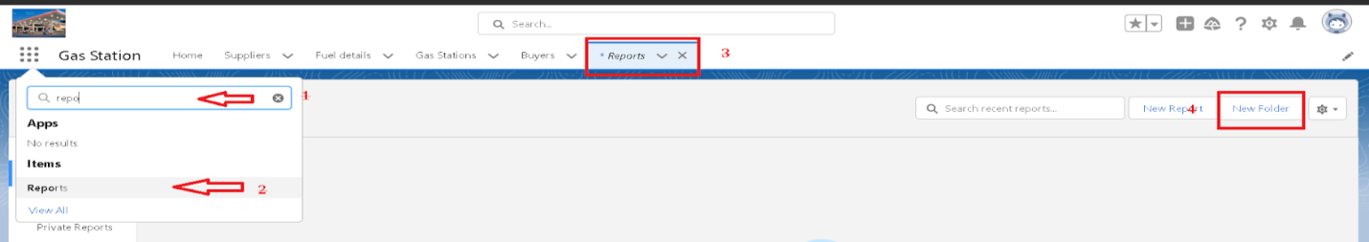

1. Give the Folder label as “estimated rice per day”, Folder unique name will be auto populated.
2. Click save.

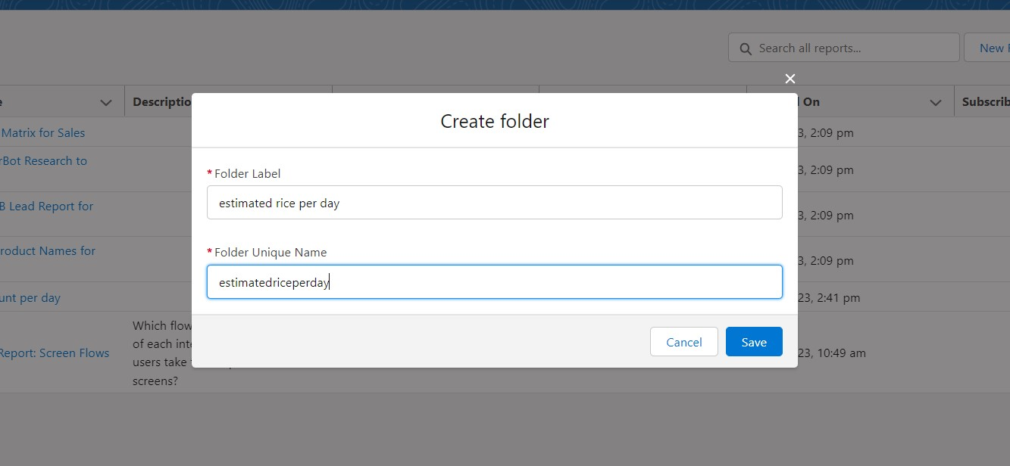

1. Navigate to app launcher and click reports on that.

2. Click all reports.

3. Select the range of amount per day drop down in that click move.

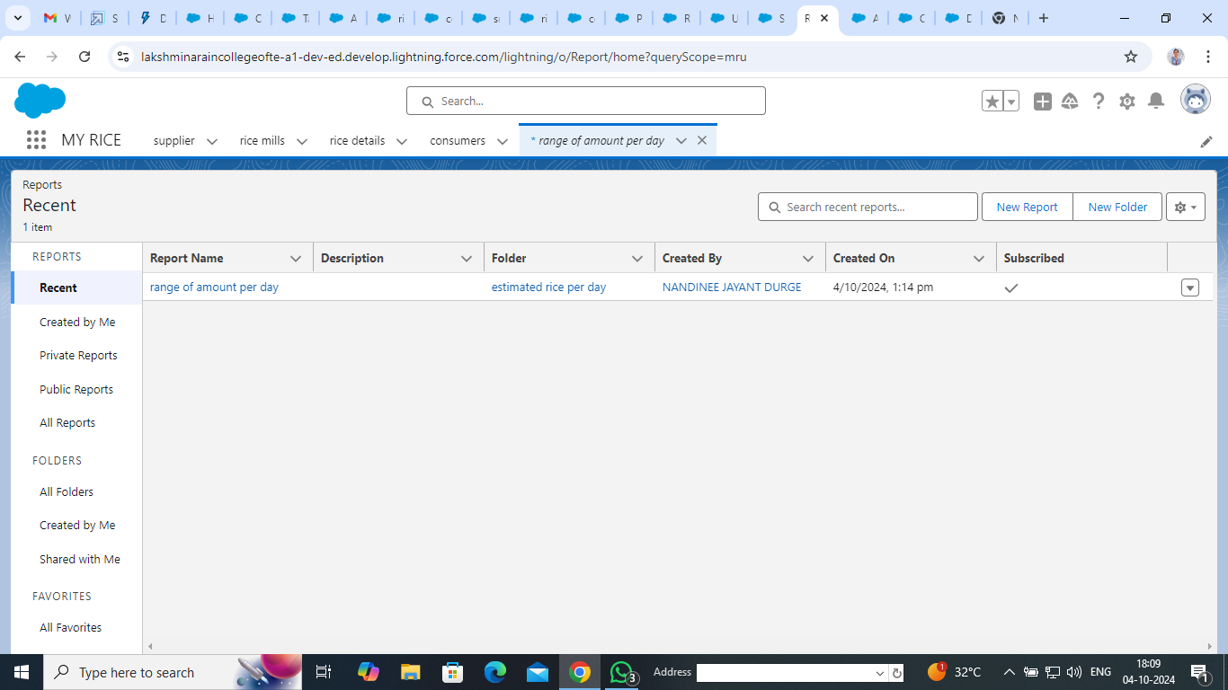

1. Select estimated rice per day folder and select folder.

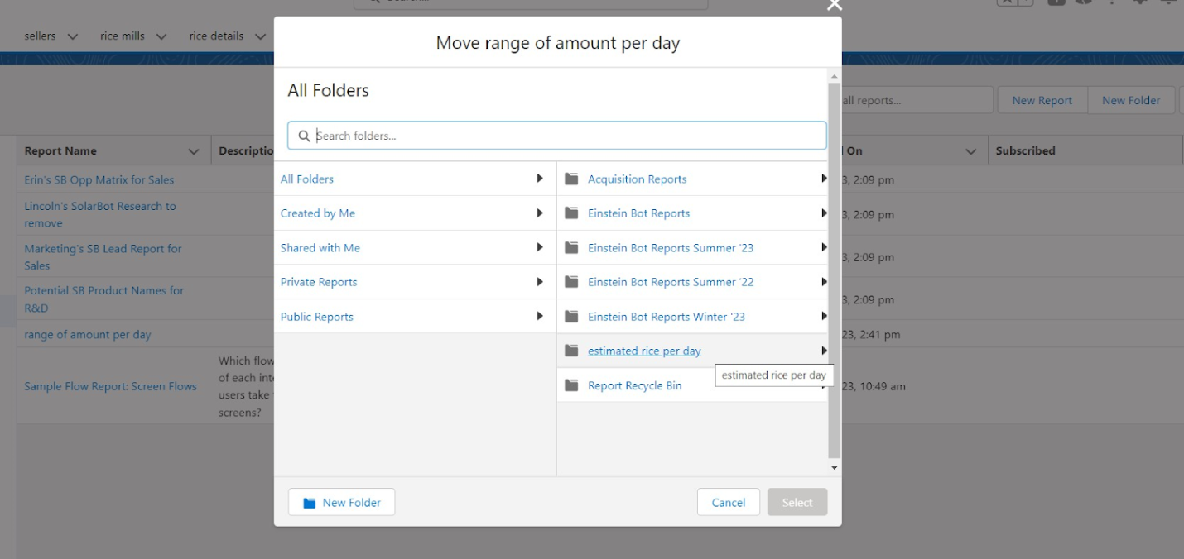

Note: if you want to see the report which you have created then go to reports - all folders - estimated rice per day - your report will appear in this way.

**Conclusion**

By setting up this subscription, you ensure that the owner stays updated with the latest report data without having to manually check the report each time.

**4.12 Dashboards**

### Dashboards are visual displays of key metrics and reports, providing a snapshot of business performance. They consist of multiple components like charts, graphs, and tables, offering insights and data visualization for decision-making

### Dashboards help you visually understand changing business conditions so you can make decisions based on the real-time data you’ve gathered with reports.

### Use dashboards to help users identify trends, sort out quantities, and measure the impact of their activities. Before building, reading, and sharing dashboards, reviews these dashboard basics.

### Basics of Dashboards 1. Components Charts: Visualize data with pie charts, bar charts, line charts, etc. Graphs: Show trends over time or comparisons between different data sets. Gauges: Display progress toward a goal or target. Tables: Present data in a grid format for detailed examination. Metrics: Highlight key performance indicators (KPIs) and summary numbers.

### 2. Dashboard Filters Global Filters: Allow users to apply filters across multiple components within the dashboard. Component Filters: Apply filters to specific components, enabling more focused analysis.

### 3. Data Sources: Dashboards pull data from reports, which need to be created and configured before building a dashboard.

### 4. User Access: Sharing: Dashboards can be shared with users or groups to ensure that relevant stakeholders have access to the information.

### 5. Refresh Settings: Dashboards can be set to refresh at specific intervals to ensure that the data displayed is up-to-date.

### 4.12.1 Create Dashboard Folder

1. Click on the app launcher and search for the dashboard.
2. Click on the dashboard tab.
3. Click the new folder; give the folder label as “amount data dashboard”.
4. Folder unique names will be auto populated.
5. Click save.

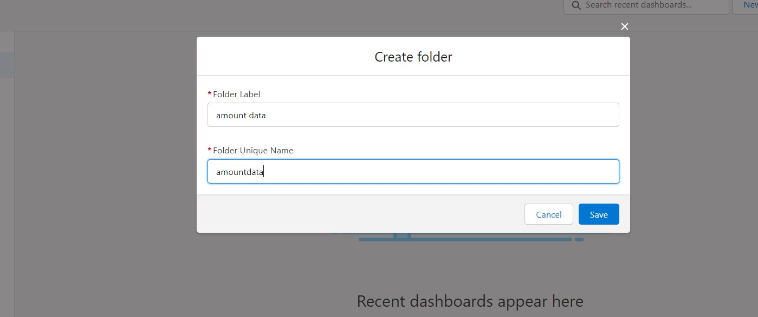

* + 1. **Create Dashboard**

1. Go to the app >> click on the Dashboards tabs.

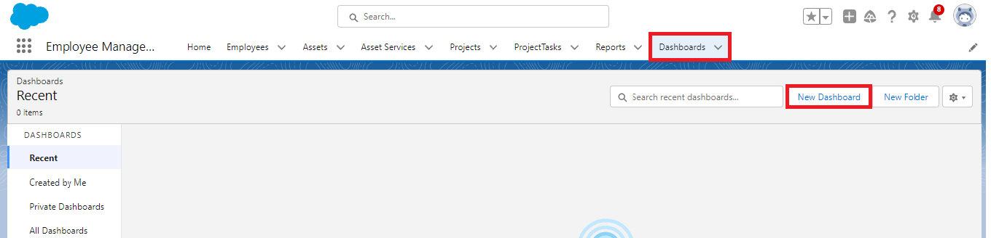

1. Give a Name and select the folder that was created, and click on create.

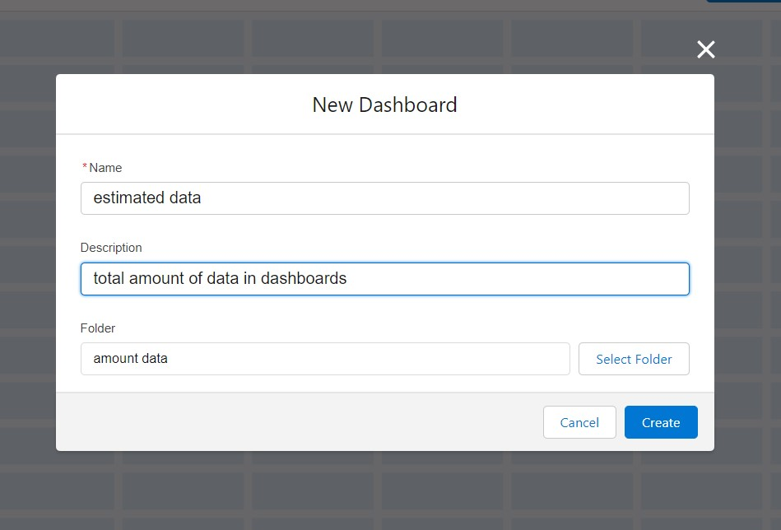

1. Select add component.



4. Select a Report and click on select.

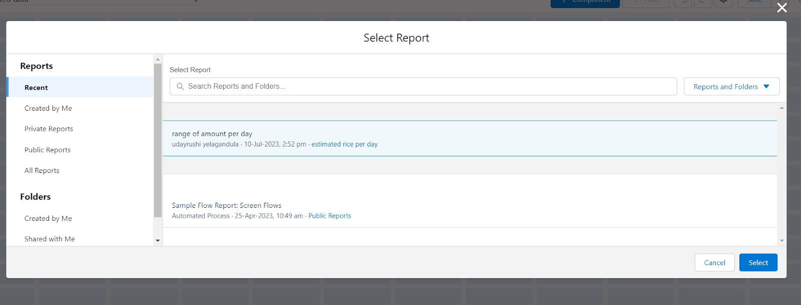

5. Preview is shown below.

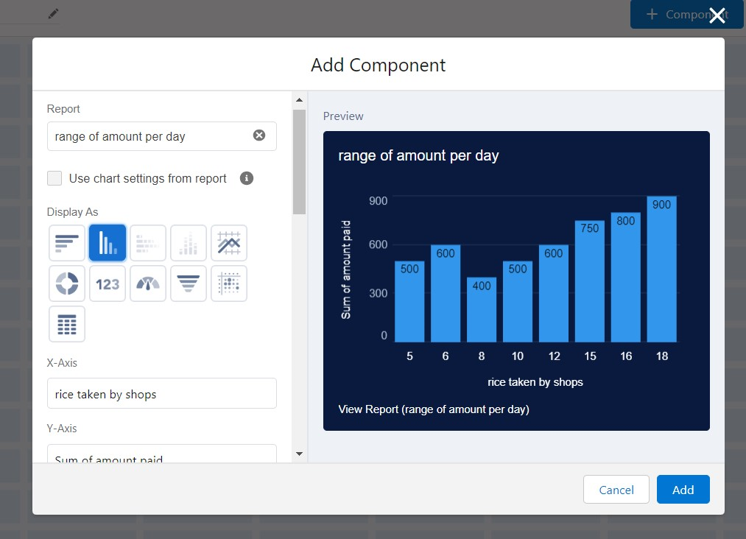

Display as>> vertical bar chart

X-axis >> rice taken by shops

Y-axis >> sum of amount

Y-axis range >> automatic

Sort by >> rice taken by shops

Component theme >> dark.

Add the component

Again select add component with above same steps

1.display  as donut chart

2.sort by >> sum of amount

3.title>>range of amount per day

4.component theme dark

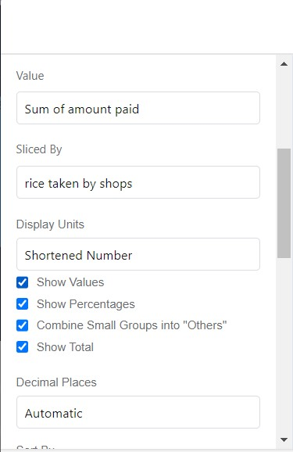

Click add.

Click save and done.

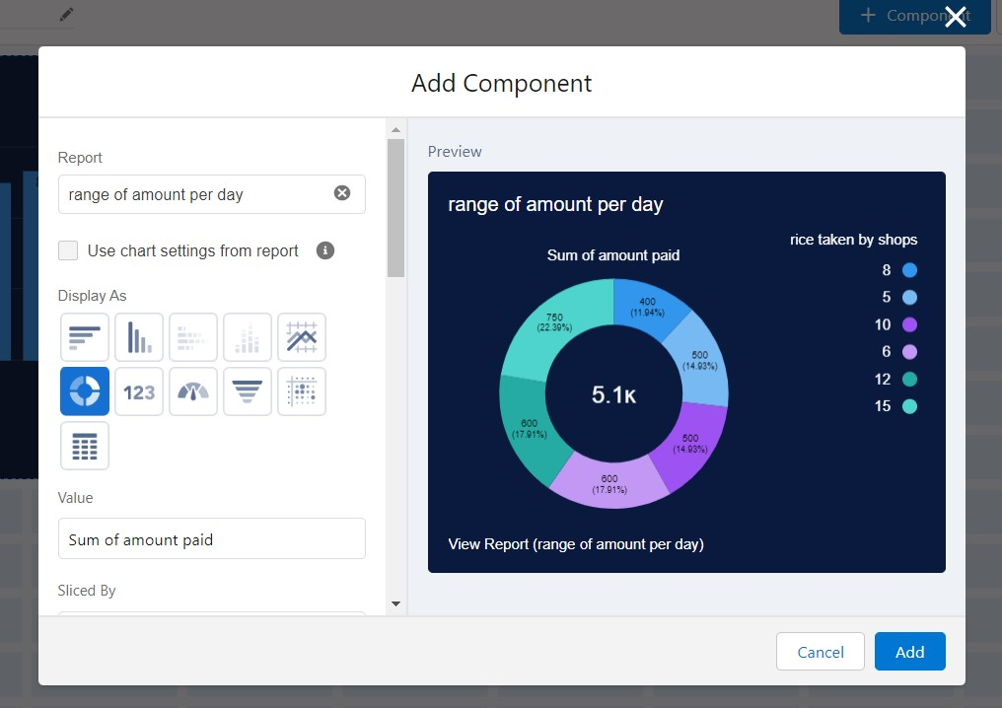

### Conclusion Your dashboard will now display the selected report data in the chosen visual format, helping you analyze and interpret your data effectively.

### 4.13 APEX

### Apex is a strongly typed, object-oriented programming language that allows developers to execute flow and transaction control statements on the Lightning platform server in conjunction with calls to the Lightning Platform? API.

### Using syntax that looks like Java and acts like database stored procedures, Apex enables developers to add business logic to most system events, including button clicks, related record updates, and Visualforce pages.

Apex code can be initiated by Web service requests and from triggers on objects. It is as similar as java i.e., it also supports OOP (Object oriented programming) like Classes, objects, methods.

**Creating Classes:**

Apex classes are modeled on their counterparts in Java. You’ll define, instantiate, and extend classes, and you’ll work with interfaces, Apex class versions, properties, and other related class concepts.

* **Class:**  
  As in Java, you can create classes in Apex. A class is a template or blueprint from which objects are created. An object is an instance of a class.
* **Object**

Object is an instance of a class, where it can access all the

Properties that are present in a class i.e., variables and methods.

**Trigger**

A trigger is a piece of Apex code that executes before or after specific database events on objects, such as insertions, updates, or deletions. Triggers are used to perform custom actions or enforce business rules.

**Objective:** To create a trigger that sends an email notification after a laptop booking record is inserted or updated.

**Overview:** A trigger in Salesforce is used to execute custom code before or after a data manipulation operation (DML event) like insert, update, or delete.

**Types of Triggers**:

**Before Triggers:** Used to perform validations or modifications before the record is saved to the database.

**After Triggers:** Used to perform operations that require the record to be saved to the database first, such as sending email notifications.

**4.13.1 Creating An Apex Class(ConsumerRecord)**

1. Login to the Salesforce account and navigate to the gear account in the top right corner.

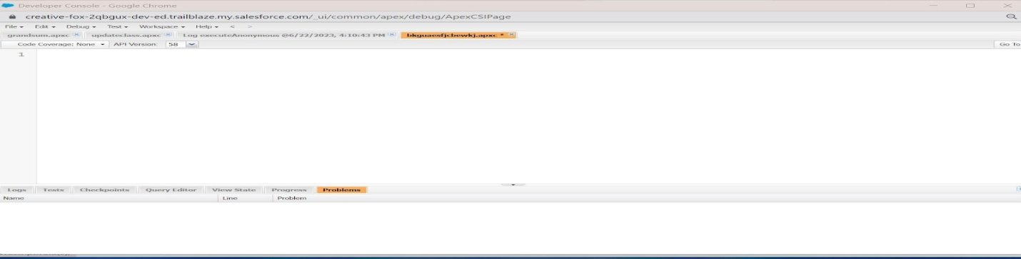

1. Then we can see the Developer console. Click on the developer console and you will navigate to a new console window.
2. Then you can see many tools in the Toolbar of the new console window. Click on File, New and Apex Class.
3. Enter the name of the class(ConsumerRecord) to create a new class file.

Code snippet:

public class ConsumerRecord {

public static void sendEmailNotification (List<consumer__c> con){

for(consumer__c c:con)

{

Messaging.SingleEmailMessage email = new Messaging.SingleEmailMessage();

email.setToAddresses( new List<String>{c.email__c});

email.setSubject('Welcome to our company');

email.setPlainTextBody('Dear ' + ' '+ ',\n\nWelcome to MY RICE!'+'You have been seen as a valuable customer to us. PLease continue your journey with us, while we try to provide you with good quality resources.'+'\n'+

'We are proud to associate with valuable customers like you and we look forward to collaborating with you by providing more and more exciting discounts or even product offers too.' + '\n'

+'So why taking a step back, take a leap of faith and shop with us more, while we provide with the valuable products and offers'+'\n'+'\n'+'\n'+

'Thankyou for buying '+ '' +'Here are some of the products that are brought by the customers who similarly bought products like this'+'\n\n');

Messaging.sendEmail(new List<Messaging.SingleEmailMessage>{email});

}

}

}

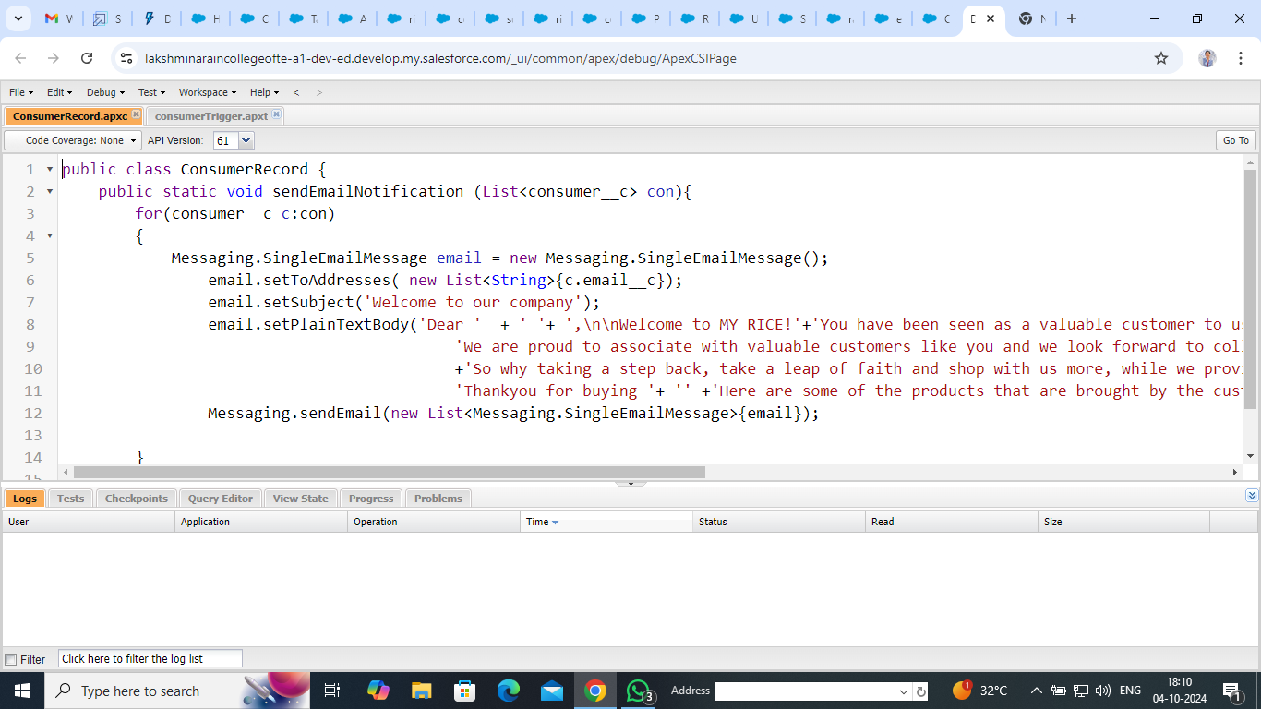

**4.13.2 Creating An Apex Trigger**

**How to create a new trigger:**

While still in the trailhead account, navigate to the gear icon in the top right corner.

Click on developer console and you will be navigated to a new console window.

Click on the File menu in the toolbar, and click on new? Trigger.

Enter the trigger name and the object to be triggered.

**Syntax For creating trigger :**

The syntax for creating trigger is :

Trigger [trigger name] on [object name]( Before/After event) {  
             //Trigger Logic

}

**Trigger code:**

trigger consumerTrigger on consumer__c (After insert) {

    if(trigger.isAfter && trigger.isInsert) {

        ConsumerRecord.sendEmailNotification(trigger.new);

    }

}

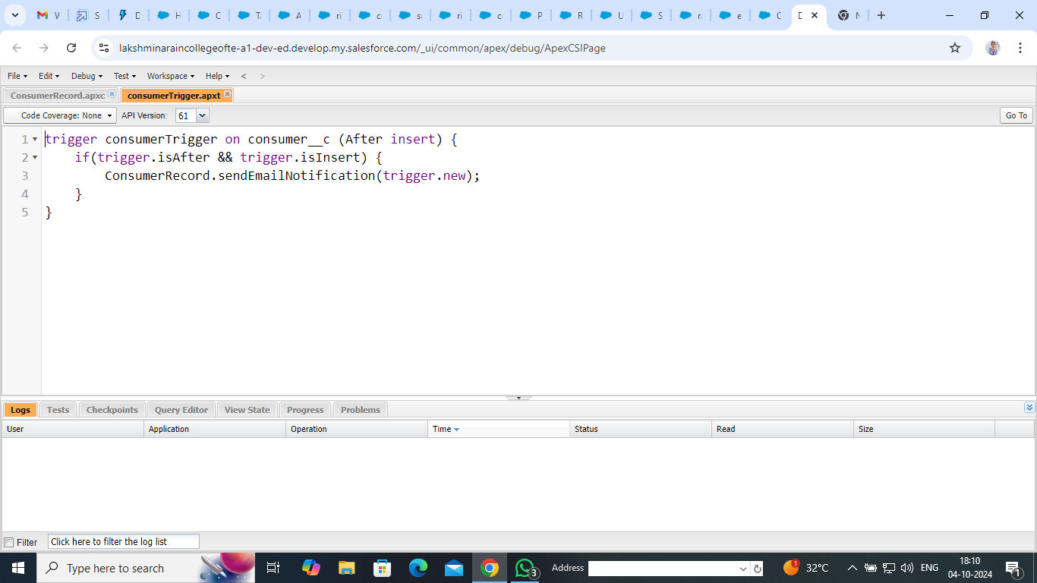

# Chapter – 5 What I Gained from the Project

Building the Rice Mill CRM Application has been an incredible journey. Here’s what I’ve accomplished and learned:

* **Hands-On Salesforce Experience**: I gained valuable experience configuring and customizing CRM applications on Salesforce, building a system tailored to the needs of a rice mill. This included setting up objects, fields, and relationships.
* **Understanding Objects & Relationships**: I learned to create and manage custom objects like Suppliers, Rice Mills, Consumers, and Rice Details, understanding how they interrelate to form an effective CRM system.
* **Developing Formula Fields and Validation Rules**: I crafted formula fields to calculate payments and implemented validation rules to ensure data integrity, preventing incorrect or incomplete records.
* **Applying Cross-Object Formula Fields**: I used cross-object formula fields to pull information from related records, allowing for essential calculations and data aggregation.
* **Designing Page Layouts**: I customized page layouts to make the application user-friendly, arranging fields and sections for easy access to data.
* **Using Rollup Summary Fields**: I implemented rollup summaries to aggregate data from child records and display it on parent records, improving inventory management.
* **Creating Reports and Dashboards**: I developed reports and dashboards to track daily sales, revenue, and popular rice types, providing valuable insights for decision-making.

Overall, this project significantly enhanced my Salesforce skills and resulted in a practical tool to improve rice mill management

# Chapter – 6 Conclusion

Reflecting on the development of the Rice Mill CRM Application, I’m very satisfied with what I’ve achieved. This project has been a valuable learning experience, helping me apply and expand my Salesforce skills in a practical setting.

The implementation of a Salesforce CRM system for a wholesale rice mill marks a significant advancement in how the business manages customer relationships, streamlines operations, and enhances its competitive edge.

The project’s main objective was to create a unified platform that integrates various business processes, centralizes customer data, and automates tasks to improve overall efficiency.

By building this CRM system, I’ve gained hands-on expertise with key Salesforce features like object creation, formula fields, and validation rules. I also learned how to design intuitive page layouts and use rollup summary fields to simplify data management. Creating customized reports and dashboards has allowed me to visualize key metrics and generate meaningful insights.

Looking forward, I’m excited about future enhancements. Whether it’s adding advanced reporting, integrating with external systems, or incorporating AI-driven analytics, there’s significant potential to further improve the CRM. I’m also keen on enhancing data security and expanding user support and training to meet the rice mill’s evolving needs.

The CRM system automates many aspects of the sales cycle, reducing manual tasks and freeing up time for sales representatives to focus on building relationships and closing deals. It allows for more accurate sales forecasting by integrating real-time data on orders, inventory, and market demand.

This real-time visibility reduces the chances of stock shortages or overproduction, leading to improved supply chain management. The Salesforce CRM system also facilitates lead tracking and management, ensuring that no potential sales opportunity is lost.

Overall, this project has sharpened my technical skills and produced a practical tool that positively impacts rice mill operations. I’m proud of the progress made and optimistic about the continued growth and value of this CRM application.

# Chapter – 7 Future Enhancements

Looking ahead, there are several exciting opportunities to enhance the Rice Mill CRM Application. Here’s what I’m envisioning:

●**Advanced Reporting Capabilities**: There’s potential to dive deeper into data by adding features like custom report filters, scheduled email updates, and interactive dashboards. This could help users better track rice sales and customer trends. Imagine detailed sales patterns over time or automatic reports on key metrics—this would make decision-making much smoother.

●**Integration with External Systems**: Seamless integration with external systems like accounting software or inventory tools could be transformative. It would eliminate manual data entry and keep financial records and inventory levels in sync.

●**Enhanced User Interface and Experience**: Improving the interface to be more intuitive, adding customizable dashboard widgets, and ensuring mobile compatibility would make the CRM more user-friendly and efficient for all users.

●**Automated Workflows and Notifications**: Setting up automated workflows and notifications can streamline operations. For example, automatic reminders for payment deadlines or inventory restocking would help avoid missed tasks and keep things running smoothly.  
  
●**Integration of AI and Analytics**: The future holds promise with AI and advanced analytics. Tools that predict trends, spot issues, or analyze customer behavior could lead to smarter decision-making and help anticipate market changes.  
  
●**Expanded User Training and Support**: To ensure everyone uses the CRM to its full potential, providing detailed user guides, video tutorials, and a support helpdesk would instill confidence and assist users in navigating the application.

These enhancements aim to make the CRM more powerful and user-friendly, and I’m excited to see how they will further optimize the rice mill's operations and drive business growth.